

CONTROL YA620A 5080
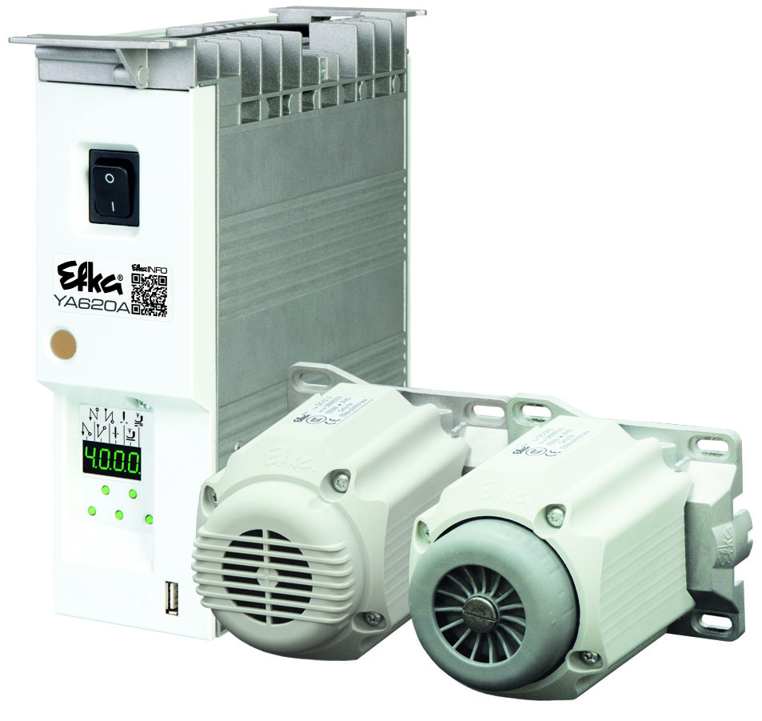
Operating manual
With parameter list

- Putting into Service
- Settings
- Functional Description
- Connection Diagrams
- Timing Diagrams

No. 402454 English

Important Notes
The particulars used in various figures and tables, such as type, program number, speed, etc.,
serve as examples. They may differ from those in your display.
For current versions of the Instructions for Use and Lists of Parameters, necessary for operating EFKA drives in accordance with regulations, please refer to the EFKA web site www.efka.net, page “Downloads”.

On our web site, you will also find the following supplementary instructions for this control:
General instructions for use and programming
Use with USB Memory Stick
- Adapter cords

CONTENTS Page

1 Use in Accordance with Regulations 5
1.1 Special Accessories 5
1.1.1 Adaptor for special machines 6
2 Quick access 6
2.1 Setting the reference position 6
2.1.1 Parameter back up 7
2.1.2 Parameter backup 7
2.1.3 Restoring parameters from the backup 8
2.1.4 Save the parameter backup on a USB stick 8
2.1.5 Restoring the parameter backup from the USB stick 9
3 Setting the Basic Functions 10
3.1 Selection of Functional Sequences (Thread Trimming Operations) 10
3.2 Functions of the Keys Inputs in1...in7 10
3.3 Positioning speed 10
3.4 Maximum Speed Compatible with the Sewing Machine 10
3.5 Maximum speed 10
3.6 Positions 11
3.7 Display of the Signal and Stop Positions 11
3.8 Positioning shift 12
3.9 Braking Characteristics 12
3.10 Braking Power at Standstill 12
3.11 Starting Characteristics 12
3.12 Actual Speed Display 13
3.13 Operating hours counter 14
3.13.1 Set and Reset Operating Hours Counter 15
3.13.2 Total Operating Hours Display 15
4 Functions with or without Control Panel 15
4.1 First Stitch after Power On 15
4.2 Softstart 15
4.2.1 Softstart speed 16
4.2.2 Softstart stitches 16
4.3 Sewing foot lifting 16
4.4 Start Stitch Condensing 17
4.4.1 Stitch Counting for Start Stitch condensing 18
4.4.2 Start Stitch Condensing 18
4.5 End Stitch Condensing 18
4.5.1 Speed n4 at the Seam End 18
4.5.2 Stitch Counting for End Stitch condensing 18
4.5.3 Stitch Correction and Last Stitch Backward 19
4.5.4 Single End Stitch condensing 19
4.6 Unlocking the Chain (Mode 5/6/7) 19
4.7 Machine run blockage 20
4.8 Speed Limitation n9 21
4.9 Thread trimming operation 21
4.9.1 Trimming speed 21
4.9.2 Chainstitch thread cutter (var. modes) 21
4.9.3 Chainstitch Machine Trimming Signal Times 21
4.10 Overlock Machine Functions (Mode F-290= 40) 22
4.10.1 Chain Suction Signal 22
4.10.2 Start and End Counts 23
4.11 Tape Cutter/Fast Scissors (Mode F-290=40) 23
4.12 Manual Tape Cutter/Fast Scissors 24
4.13 Seam with Stitch Counting 24
4.13.1 Number of Stitches for a Seam with Stitch Counting 24
4.13.2 Stitch Counting Speed 24
4.13.3 Seam with Stitch Counting When Light Barrier Is On 25
4.14 Free Seam and Seam with Light Barrier 25
4.15 Light barrier 25
4.15.1 Speed after Light Barrier Sensing 25
4.15.2 General Light Barrier Functions 25
4.15.3 Reflection Light Barrier LSM002 26
4.15.4 Automatic Start Controlled by Light Barrier 26
4.15.5 Light barrier filter for knitted fabrics 27
4.15.6 Functional Variations of the Light Barrier Input 27
4.16 Switching Functions of Inputs in1...i13 27
4.17 Software Debouncing of All Inputs 28
4.18 F1/F2 Function Key Assignment on the V810/V820 Control Panels 28
4.19 Special pedal function Single stitch / Full stitch 29
4.20 Signal “Machine Running“ 29
4.21 Signal Output Position 1 30
4.22 Signal Output Position 2 30
4.23 Signal Output 512 Impulses per Rotation 30
4.24 Actuator 30
4.24.1 Analog actuator 30
5 Signal Test 30
5.1 Signal Test Using the Incorporated Control Panel or the V810/V820 31
5.1.1 Inputs to the control 31
5.1.2 Outputs of control 32
6 Table of Machine Functions and Adapter Cords 32
7 Operating Elements and Socket Connectors 33
7.1 Positions of the Front Side 33
7.2 Positions of the rear side 33
7.3 Connection Diagrams 34
8 Timing Diagrams 39
Mode 0-5 (chainstitch 39
8.1 Operator Level 41
8.2 Technical level (Code no. 1907) 43
8.3 Supplier level (Code No. 3112) 49
9 Error Displays 57

Use in Accordance with Regulations
The drive is not an independent functional machine. It has been designed for integration into other machines by trained specialists.
It must not be put into service until the machinery into which it is to be incorporated has been declared in conformity with the provisions of the EC Directive (Appendix II, paragraph B of the Directive 89/392/EEC and supplement 91/368/EEC).

The drive has been developed and manufactured in accordance with the relevant EC standards:

IEC/EN 60204-31 Electrical equipment of industrial machines:
Particular requirements for industrial sewing machines, sewing units and sewing systems.

Operate the drive only in dry areas.

 | Attention  When selecting the installation site and the layout of the connecting cable, the Safety Instructions must be followed with no exceptions.  Particular attention should be paid to maintaining the proper distance from moving parts!

Special Accessories
The special accessories available ex works allow the augmentation and enhancement of functions, operating, connecting, and mounting options.
Since the range of available components is continually expanded, we kindly ask you to contact us in case of need.

Designation | Material No.
Control panel Variocontrol V810 | 5970153
Control panel Variocontrol V820 | 5970154
Reflection light barrier module LSM002 | 6100031
Hall sensor module HSM001 | 6100032
Pulse encoder IPG001 | 6100033
Adapter cord for the connection of light barrier module and/or Hall sensor module HSM001 and/or pulse encoder IPG001 | 1113229
Extension cable approx. 1000 mm long for commutation transmitter DC12.. + DC15.. | 1113151
Extension cable approx. 1000 mm long for Netz DC12.. line + DC15.. | 1113931
Potential equalization cord 700 mm long, LIY 2.5 mm², gray, with spades on both sides | 1100313
Foot control type FB302B with three pedals for standing operation, with  approx. 1400 mm connecting cable and plug | 4170025
Fitting piece for position transmitter | 0300019
Knee switch type KN19 (pushbutton) with cord of approx. 450 mm length and western plug (RJ11) | 5870021
Knee switch type KN20 (pushbutton + selector switch ) with cord of approx.  1640 mm length and Western plug (RJ11) | 5870022
Undertable mounting kit for DC1250 | 1113956
Undertable mounting kit for DC1550 | 1113427
9-contact SubminD male connector | 0504135
9-contact SubminD female connector | 0504136
Half-shell housing for 9-contact SubminD | 0101471
37-contact SubminD male connector, complete | 1112900
Single pins for 37-contact SubminD with strand of 50 mm length | 1112899

Mounting brackets DirectDrive DC1210 & DC1230
HMB bracket for DC1230 on YAMATO VC, VE, VF | 1114102
HMB bracket for DC1230 on YAMATO VG | 1114143

Adaptor for special machines
Connection diagrams of the adapter cables can be found on our homepage at www.efka.net/downloads.

Machine / type / class | Material No.
Mounting bracket for DC1230 on YAMATO VC, VE, VF, VG | 1114134

Quick access

These are button combinations that are linked in the direct access with settings & function of the control. Quick access can, however, can only be used with machines that are already set up.

Setting the reference position

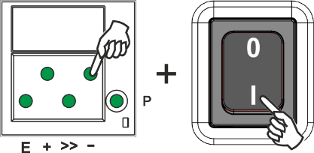 |  | 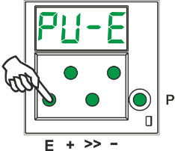 |  | 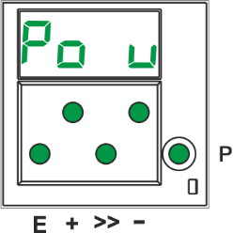
- Hold down the button and switch on the controls  - (Until Pos0 show for 1 second) |  | - Press the E button |  | - "P0" and a rotating "u" are displayed
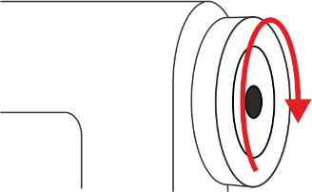 |  | 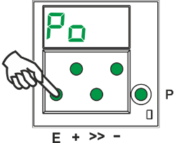 |  | 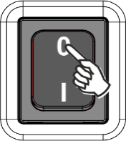
- Turn the handwheel until the rotating "u" disappears  - Bring the handwheel to the zero position (needle up / OT) |  | - Press the E button |  | - Turn off
Note: If the rotating "u" does not disappear after 10 rotations, change the direction of rotations.

Parameter back up

When the machine has been completely set up, the settings should be backed up.

Parameter backup
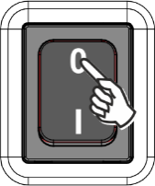 |  | 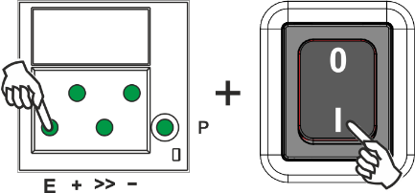 |  | 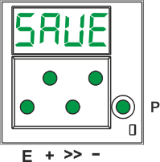
- Turning off the controls |  | - Hold the E button down & turn on the controls  - (Hold down the E button 5 sec after turning on) |  | - "SAVE" is shown on the display
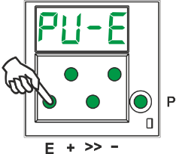 |  | 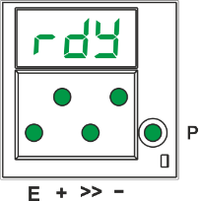
- Press the E button once, to execute the backup process |  | - When the process is completed, "rdy" is displayed for 1 second |  | - Turning off the controls

Restoring parameters from the backup

 |  | 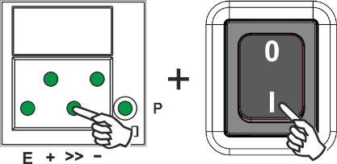 |  |  |  | 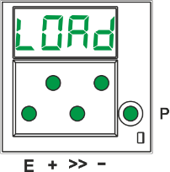
- Turning off the controls |  |  | - >>-Hold the button down (5 sec) & turn on controls |  |  | - "LOAD" is shown on the display
 |  |  | 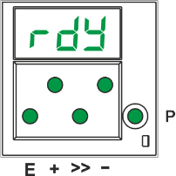
- Press the E button once, to execute the backup process |  |  | - When the process is completed, "rdy" is displayed for 1 second |  |  | - Turning off the controls

Save the parameter backup on a USB stick

(The parameters can be views with a text editor or Microsoft Word. The parameters in this file must not be changed!)

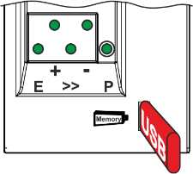 |  | 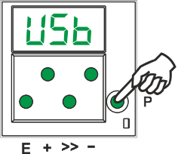 |  | 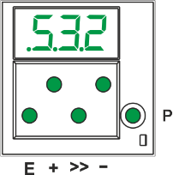
- Insert an empty USB Stick |  | - Wait until "USB" shows on the display and press the P key  - Use the +/- buttons to get to parameter F-532. (".5.3.2" is shown on the display) |  | - Use the +/- buttons to get to parameter F-532. (".5.3.2" is shown on the display)
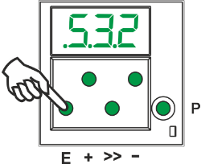 |  | 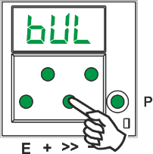 |  | 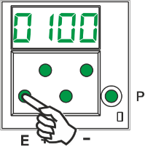
- Press the E button once |  | - Press the >> button |  | - Press the E button
- When the process is completed, "rdy" is displayed for 1 second |  | - Turn off

Restoring the parameter backup from the USB stick

This process does not change the actual parameter settings. To load the backup to the current parameter setting, execute Chapter 5.1.2 "Restoring parameters from backup". (After this process)

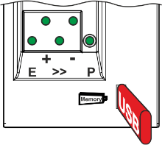 |  | 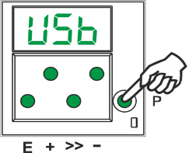 |  | 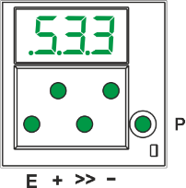
- Insert the USB stick with the file "0100DATA.PAB" |  | - Wait until "USB" shows on the display and press the P key  - Use the +/- buttons to get to parameter F-533. (".5.3.3" is shown on the display) |  | - Use the +/- buttons to get to parameter F-533. (".5.3.3" is shown on the display)
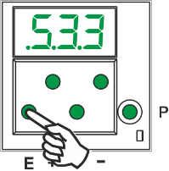 |  | 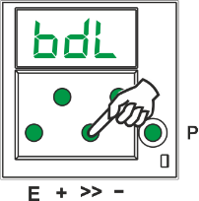 |  | 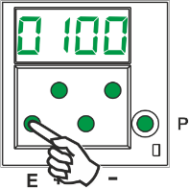
- Press the E button once |  | - Press the >> button |  | - Press the E button
 |  | 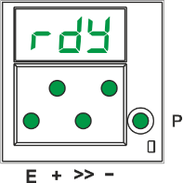
- Press the E button once, to execute the backup process |  | - When the process is completed, "rdy" is displayed for 1 second |  | - Turn off

Setting the Basic Functions

Selection of Functional Sequences (Thread Trimming Operations)
This drive is suitable for different lockstitch, chainstitch and overlock machines. The mode for the functional sequence required on the respective machine can be selected using parameter 290.

Attention
Before switching the functional sequences, you must disconnect input and output plug-and-socket connections between control and machine. Please ensure that the functional sequence (mode) suitable for the respective machine is selected.
Settings with parameter 290 are possible only after the power is turned On.

You will find a summary of the modes that can be set and the corresponding machines and adapter cords, to include available output signals in the List of Parameters chapter: Table of adapter cords.

Further information see chapter "Timing Diagrams" for the various modes.

Functions of the Keys Inputs in1...in7
The function that is started when a button or switch connected to one of the inputs in1 to in7 is actuated can be selected using parameters 240...246.
The possible functions are listed in the section "Parameter list".

Positioning speed
Function with or without control panel |  | Parameters
Positioning speed | (n1) | 110

The positioning speed can be set using parameter 110 on the control within a range of 70...390 RPM.

Maximum Speed Compatible with the Sewing Machine
The maximum speed of the machine is determined by the selected pulley and by the following settings:
- Set the maximum speed using parameter 111 (n2).
- Set the maximum speed limitation to the specific level according to the application as described in chapter "Direct Input of Maximum Speed Limitation (DED)".

Maximum speed
Function with or without control panel |  | Parameters
Maximum speed | (n2) | 111

Note
See instruction manual of the sewing machine manufacturer for the maximum speed of the sewing machine.

Note
Select the pulley such that the motor runs at approx. 4000 RPM with max. number of stitches.

Positions

Function with or without control panel |  | Parameters
Mode for the position sensor  Transmission ratio between motor shaft and machine shaft | (PGm)  (trr) | 270  272

A sensor can be used as a position sensor, e.g. Efka Hall sensor module (HSM1) or pulse generator (IPG) with either NC or NO functionality.
It is connected to socket B18/7.
Parameter 270 is used to select the mode to be selected depending on the type and mounting of the sensor used (see section Parameter List under parameter 270 for a description and flow chart).
After configuration of parameter 270 to "1, 2, 3 o 4 The positions can be configured using the fast-installation routine.
The transmission ratio must already have been input using parameter 272.

Display of the Signal and Stop Positions
Function with or without control panel |  | Parameters
Display of positions 1 and 2 | (Sr3) | 172

The position settings can easily be checked by means of parameter 172.
- Select parameter 172
- The control panel display shows "Sr3"
- Turn hand wheel according to the direction of motor rotation

Control display (control panel not connected)
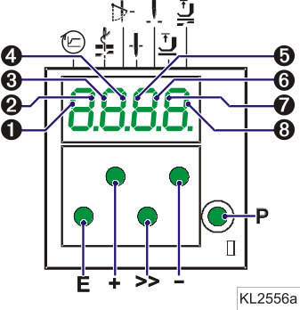
- Segment |  | is turned on | corresponds to position 1 On
- Segment |  | is turned off | corresponds to position 1 Off
- Segment |  | is turned on | corresponds to position 2 On
- Segment |  | is turned off | corresponds to position 2 Off

V810 / V820 control panel display

- Arrow above symbol "position 1" on key 4 (V810) / on key 7 (V820) is displayed | corresponds to position 1 On
- Arrow above symbol "position 1" on key 4 (V810) / on key 7 (V820) is displayed | corresponds to position 1 Off
- Arrow above symbol "position 2" on key 4 (V810) / on key 7 (V820) is displayed | corresponds to position 2 On
- Arrow above symbol "position 2" on key 4 (V810) / on key 7 (V820) is displayed | corresponds to position 2 Off

If the V810 or V820 control panel is connected, the positions will be displayed only on the control panel!

Positioning shift
Function with or without control panel |  | Parameters
Positioning shift | (PSv) | 269

Determine by means of parameter 269 whether the drive is to stop exactly on the position (Parameter 269 =0) or some increments after the position.

Braking Characteristics
Function with or without control panel |  | Parameters
Braking ramp running  Braking ramp stop  Braking ramp for n < 350 when drive stopped | (br1)  (br2)  (br3) | 207  208  219

- Parameter 207 regulates the braking effect between speed stages
- Parameter 208 influences the braking effect for the stop
- Parameter 219 influences the braking effect before the stop

The following applies to all setting values: the higher the value, the stronger the braking reaction!

Braking Power at Standstill
Function with or without control panel |  | Parameters
Braking Power at Standstill | (brt) | 153

This function prevents unintentional "wandering" of the needle at standstill.
The effect can be checked by turning the hand wheel.

- The braking power is effective at standstill
- at stop in the seam
- after the seam end
- The effect can be set
- The higher the set value, the stronger the braking power

Starting Characteristics
Function with or without control panel |  | Parameters
Starting edge | (ALF) | 220

The drive acceleration dynamics can be adapted to the sewing machine characteristic (light/heavy).

- High setting value = high acceleration

With a high starting edge setting and, in addition, possibly high braking parameter values on a light machine, the characteristic may appear coarse. In this case, one should try to optimize the settings.

Actual Speed Display
Function with control panel |  | Parameters
Display actual speed | (nIS) | 139

If parameter 139 = 1, the V810/V820 display shows the following information:

 |  | V810 | V820
During operation:  - The actual speed  - Example: 2350 revolutions per minute
  ➔
  2350
  2350
At stop in the seam:  - The stop indication
  ➔
  StoP
  StoP
At standstill after trimming:  - On the V810, indication of the type of control  - On the V820, indication of the set maximum speed and the type of control  Example: 4000 revolutions per minute and type of control AB425S
  ➔
  YA620A
  4000 YA620A

Operating hours counter
Function with or without control panel |  | Parameters
Service routine for total operating hours  Service routine for operating hours before service  Input of operating hours before service | (Sr6)  (Sr7)  (Sr) | 176  177  217

The integrated operating hours counter records the time of motor operation. Downtimes are not recorded. Time recording accuracy is 1ms. There are two ways of operating hours counting.

1. Basic operating hours counting:
217 =0 | Operational mode: Operating hours counting

2. Service Hours Monitoring:

217 =>0 | Operational mode: Number of operating hours before the next service.  Input of operating hours before the next service.  This value is compared to the operating hours counter.  The input of hours is done in steps of 10. i. e. the lowest display of 001 corresponds to 10 hours  (e. g. 055 = 550 hours).  When the set number of operating hours are reached, the message "C1" will show on the display after each trimming operation. In addition, the speed indicator blinks on the control or on the V820 control panel during operation or after drive standstill.  Moreover, an acoustic signal is emitted when using a V810/V820 control panel if parameter 127=1.
176 | In this service routine, the total operating hours can be read out according to the procedure example described below for parameter 177.
177 | Display of operating hours since the last service.

Display example of operating hours or hours since the last service and operating hours counter reset.

Display on the control:
- Select parameter 177
- Press the E key | ➔ | Sr7
- Press the >> key | ➔ | h t | (hours /thousands letter symbol)
- Press the E key | ➔ | 000 | hours /thousands display)
- Press the E key | ➔ | h h | (hours / hundreds letter symbol)
- Press the E key | ➔ | 000 | (hours / hundreds display)
- Press the E key | ➔ | Min | (minutes letter symbol)
- Press the E key | ➔ | 00 | (minutes display)
- Press the E key | ➔ | SEc | (seconds letter symbol)
- Press the E key | ➔ | 00 | (seconds display)
- Press the E key | ➔ | MS | (milliseconds letter symbol)
- Press the E key | ➔ | 000 | (milliseconds display)
- Press the E key | ➔ | rES | See chapter "Set and Reset Operating Hours Counter"
- Press the E key | ➔ |  | The process will be repeated from the hours display.
- Press the P key twice | ➔ | e.g. 400 | (sewing process can be started)

Display on the V810 control panel:
- Select parameter 177
- Press the E key | ➔ | Sr7 [°]
- Press the >> key | ➔ | hoUr | (hours letter symbol)
- Press the E key | ➔ | 000000 | (hours display)
- Press the E key | ➔ | Min | (minutes letter symbol)
- Press the E key | ➔ | 00 | (minutes display)
- Press the E key | ➔ | SEc | (seconds letter symbol)
- Press the E key | ➔ | 00 | (seconds display)
- Press the E key | ➔ | MSEc | (milliseconds letter symbol)
- Press the E key | ➔ | 000 | (milliseconds display)
- Press the E key | ➔ | rES F2 | See chapter "Set and Reset Operating Hours Counter"
- Press the E key | ➔ |  | The process will be repeated from the hours display.
- Press the P key twice | ➔ | e.g. YA620A | (sewing process can be started)

Display on the V820 control panel:
- Select parameter 177
- Press the E key | ➔ | F-177 | Sr7 [°]
- Press the >> key | ➔ | hoUr | 000000 | (hours display)
- Press the E key | ➔ | Min | 00 | (minutes display)
- Press the E key | ➔ | Sec | 00 | (seconds display)
- Press the E key | ➔ | MSEc | 000 | (milliseconds display)
- Press the E key | ➔ | rES | F2 | See chapter "Set and Reset Operating Hours Counter"
- Press the P key twice | ➔ | e.g. 4000 | YA620A | (sewing process can be started)

Set and Reset Operating Hours Counter
The number of hours has been reached (service necessary):
- Press the >> key once | ➔ | The operating hours counter is set to "0" and restarted.

The number of hours has not yet been reached:
- Press the >> key three times | ➔ | The operating hours counter is set also to "0" and restarted.

A value in parameter 177 has been changed:
- After displaying rES ..., when the E key is pressed again, SEt will then be displayed.
- If the changed value is to be saved, press the >> key 3 times.

Total Operating Hours Display
In this service routine enabled using parameter 176, the total number of operating hours is displayed.
The sequence of displayed values is as with parameter 177.
The values can only be displayed, not varied. Therefore, letter symbols "rES" for "reset" and "SEt" for "set"
will not appear.

Functions with or without Control Panel

First Stitch after Power On
Function with or without control panel |  | Parameters
1 stitch at positioning speed after power On | (Sn1) | 231

If parameter 231 is on, the first stitch after power on will be performed at positioning speed for the protection of the sewing machine. This is independent of the pedal position and the softstart function.

Softstart
Function with or without control panel |  | Parameters
Softstart On/Off | (SSt) | 134

Functions:
- After power on
- At the beginning of a new seam
- Speed pedal controlled and limited to (n6)
- Lower speed of a parallel function prevailing (e. G. Stitch count)
- Stitch counting synchronized to position 1
- Suspension with pedal in position 0 (neutral)
- Interruption by full heelback (position -2)

When using the V820 control panel, direct access by means of the function key (key 9) is possible!

Function with control panel |  | Parameters
Softstart On/Off | (-F-) | 008 =1

Softstart speed
Function with or without control panel |  | Parameters
Softstart speed | (n6) | 115

Softstart stitches
Function with or without control panel |  | Parameters
Number of softstart stitches | (SSc) | 100

Sewing foot lifting
Function without control panel |  | Control
Automatic in the seam  Automatic after thread trimming | Segment 7 on  Segment 8 on | Key – (S4)

Function with control panel |  | V810 | V820
Automatic in the seam  Automatic after thread trimming  If parameter 290 = 16, with slide-in strip "7" | Left-hand arrow above key On  Right-hand arrow above key On  Left-hand arrow above key On | Key 3  Key 3 | Key 6  Key 6  Key 9

Function |  | Parameters
Automatic sewing foot with pedal forward at the seam end if light barrier or stitch counting is On  Coupled thread tension release and sewing foot lifting. The function can be activated only with a thread trimmer that depends on the angle.  Switch-on delay with pedal in position –1  Start delay after disabling the sewing foot lifting signal  Time of full power of sewing foot lifting  Duty ratio (ED) with pulsing  Delay after thread wiping until sewing foot lifting  Delay after thread trimming without thread wiper until sewing foot lifting  Upper limit ON period of sewing foot lifting 1...100 | (AFL)  (FSP)  (t2)  (t3)  (t4)  (t5)  (t7)  (tFL)  (EF-) | 023  024  201  202  203  204  206  211  254

Sewing foot is lifted:
- in the seam
by heelback (position -1)
or automatically (using the - S4 key on the control, segment 7 lights up)
or automatically (using key 3 on the V810 control panel)
or automatically (using key 6 on the V820 control panel)
by pressing a key depending on the pre-selection of parameters 240...246
- after thread trimming
by heelback (position -1 or -2)
or automatically (using the - S4 key on the control, segment 8 lights up)
or automatically (using key 3 on the V810 control panel)
or automatically (using key 6 on the V820 control panel)
by pressing a key depending on the pre-selection of parameters 240...246
automatically by light barrier when pedal forwards, according to the setting of parameter 023
automatically by stitch counting when pedal forwards, according to the setting of parameter 023
Switch-on delay after thread wiper (t7)
Switch-on delay without thread wiper (tFL)

It is possible to prevent unintentional foot lifting before thread trimming when changing from pedal position 0 (neutral) to position -2 by setting a switch-on delay (t2) using parameter201.

Holding power of the lifted foot:
The sewing foot is lifted by full power. Then the system switches automatically to partial power in order to reduce the load for the control and the connected solenoid.
Set the duration of full power using parameter 203 and the partial holding power using parameter 204.

Attention
If the holding power is set too high, the solenoid and the control may be permanently damaged. Please observe the permissible duty ratio (ED) of the solenoid and set the appropriate value according to the table below.

Value | Duty ratio (ED) | Effect
1 | 1 % | Low holding power
100 | 100 % | High holding power (full power)

Sewing foot lowers:
- Press pedal to position 0 (neutral)
- Press pedal to position ½ (slightly forward)
- Release key for manual sewing foot lifting
Upon pressing the pedal forward from lifted sewing foot, the start delay (t3) that can be set using parameter 202 becomes effective.

Start Stitch Condensing
Function without control panel |  | Control
Start stitch condensing On; number of stitches with stitch regulator (Parameter 001)  Start stitch condensing On; number of stitches without stitch regulator  (Parameter 000) after that number of stitches with stitch regulator (Parameter 001)  Start stitch condensing Off | Segment 1 on  Segment 2 on  Both segments off | Key E (S2)

Function with control panel |  | V810/V820
Start stitch condensing On; number of stitches with stitch regulator (Parameter 001)  Start stitch condensing On; number of stitches without stitch regulator  (Parameter 000) after that number of stitches with stitch regulator (Parameter 001)  Start stitch condensing Off | Left-hand arrow above key On, right-hand arrow above key On  Both arrows Off | Key 1

The start stitch condensing starts by pressing the pedal forward at the beginning of the seam. From lifted sewing foot the Stitch condensing is delayed by the time t3 (start delay after switching off the sewing foot lifting signal). Start Stitch condensing as well as start stitch condensing are executed automatically at speed n3. They cannot be interrupted. If softstart is running parallel, the respective lower speed is prevailing. The stitch regulator will be switched off after completion of the stitch count (Parameter 001) and the speed n3 after a delay time t1. Then pedal control is returned. The stitch regulator and counter are synchronized to position 1.

Stitch Counting for Start Stitch condensing
Function with or without control panel |  | Parameters
Number of stitches forward or without stitch regulator  Number of stitches backward or with stitch regulator | (c2)  (c1) | 000  001

The start Stitch condensing stitches with or without stitch regulator can be programmed and varied using the above parameters directly on the control or on a connected V810/V820 control panel.
For fast operator information (HIT) when using the V820 control panel, the value of the function switched on using key 1 can be displayed for approx. 3 seconds. During this time, the value can be varied directly by pressing key + or -.

Start Stitch Condensing
The stitch regulator signal will be issued and the backward section and/or start stitch condensing will be executed for a number of stitches that can be set.

End Stitch Condensing
Function without control panel |  | Control
End stitch condensing On; number of stitches with stitch regulator (Parameter 002)  End stitch condensing on; stitch count with stitch regulator (Parameter 002 ), afterwards the stitch count without the stitch regulator (Parameter 003).  End stitch condensing Off | Segment 3 on  Segment 4 on  Both segments off | Key + (S3)

Function with control panel |  | V810 | V820
End stitch condensing On; number of stitches with stitch regulator (Parameter 002)  End stitch condensing on; stitch count with stitch regulator (Parameter 002 ), afterwards the stitch count without the stitch regulator (Parameter 003).  End stitch condensing Off | Left-hand arrow above key On, right-hand arrow above key On  Both arrows Off | Key 2 | Key 4

The end Stitch condensing in a seam with stitch counting starts by heelback at the end of counting, or, from the light barrier seam at the end of the light barrier compensating stitches. The stitch regulator is immediately enabled from machine standstill. After lowering the sewing foot, the switch-on point of the stitch regulator is delayed by the time t3 (start delay after switching off the sewing foot lifting signal). The first leading edge of position 1 counts as 0 stitch whenever the function is not started in position 1. The stitch regulator is synchronized to position 1. End Stitch condensing as well as end stitch condensing are executed automatically at speed n4. They cannot be interrupted. From full machine run, end Stitch condensing will be switched in only after having reached the speed n4 and synchronization to position 2.

Speed n4 at the Seam End
Function with or without control panel |  | Parameters
End Stitch condensing speed | (n4) | 113

Stitch Counting for End Stitch condensing
Function with or without control panel |  | Parameters
Number of stitches forward or without stitch regulator  Number of stitches backward or with stitch regulator | (c3)  (c4) | 002  003

The end Stitch condensing stitches with or without stitch regulator can be programmed and varied using the above parameters directly on the control or on a connected V810/V820 control panel.
For fast operator information (HIT) when using the V820 control panel, the value of the function switched on using key 4 can be displayed for approx. 3 seconds. During this time, the value can be varied directly by pressing key + or -.

Stitch Correction and Last Stitch Backward
Function with or without control panel |  | Parameters
Last stitch backward On/Off  Stitch correction time | (FAr)  (t9) | 136  151

The Stitch condensing solenoid can be delayed in the double end Stitch condensing by selecting a stitch correction time (t9) using parameter 151.
For some sewing procedures it is desirable that the Stitch condensing solenoid in the single end Stitch condensing is disabled only after trimming. This function can be selected using parameter 136.
136 =0 | Trimming stitch backward Off
136 =1 | Trimming stitch backward On with single end Stitch condensing
136 =2 | Trimming stitch or positioning stitch always backward at the seam end

Single End Stitch condensing
The stitch regulator signal will be issued and the backward section and/or end stitch condensing will be executed for a number of stitches that can be set. During the last stitch the speed is reduced to positioning speed.

When using the V820 control panel, direct access by means of the function key (key 9) is possible!

Function with control panel |  | Parameters
Stitch condensing repetition On/Off | (-F-) | 008 =8

Unlocking the Chain (Mode 5/6/7)
Function with or without control panel |  | Parameters
Number of run-out stitches when unlocking the chain  Function “unlock the chain” in modes 5, 6 and 7 | (c6)  (mEk) | 184  190

Upon unlocking the chain at the seam end, the functions thread trimming and tape cutter/fast scissors are automatically suppressed. When setting parameter 190 = 3, the function tape cutter/fast scissors is however possible. After pressing the key "unlocking the chain" and with pedal in position 0 (neutral), the drive always stops in position 1.

Settings necessary for the operation “unlocking the chain”:
- Set “unlock the chain” using parameter 190 =1 / 2 / 3 / 4 (190 =0 “unlock the chain” off)
- Set switch-on delay using parameter 181 and reversing angle using parameter 180
- Determine the function of the key “unlock the chain” using one of the parameters 240...246
- If parameter 290 is set at“

190 =0 | Unchaining switched off
190 =1 | Sequence with pedal in position -2 from machine run or from position 2:  - Press key "unlock the chain"  - Run at positioning speed to position 1  - Sequence of reversing angle at positioning speed after a switch-on delay that can be set

190 =1 | Sequence with pedal in position -2 from standstill in position 1:  - Press key "unlock the chain"  - Run at positioning speed to position 1  - Sequence of reversing angle at positioning speed after a switch-on delay that can be set
190 =2 | Automatic sequence with light barrier at the seam end without tape cutting / pedal in position –2 according to the setting of parameter 019  - Press key "unlock the chain"  - Run to position 1 after light barrier sensing  - Sequence of reversing angle at positioning speed after a switch-on delay that can be set
190 =3 | Automatic sequence with light barrier on the seam end with tape cutter and run-out stitches(Only possible in mode 7 and if parameter 018 =0 )  - Press key "unlock the chain"  - After light barrier detection, sequence of the compensation stitches and end count up to tape cutting  - Run-out stitches up to unlocking the chain, adjustable with parameter 184  - Sequence of reversing angle at positioning speed after a switch-on delay that can be set
190 =4 | Sequence with pedal in position –2 / no unlocking of the chain if seam end with light barrier, cutting and run-out stitches is set:  - Press the pedal to position -2  - Run at positioning speed to position 1  - Sequence of reversing angle at positioning speed after a switch-on delay that can be set  - No unlocking of the chain at the seam end with light barrier  - Reverse motor rotation is suppressed when the drive stops. The signals “blow fabric onto stack”, M2 and “sewing foot lift” will be issued.

When using the V820 control panel, direct access by means of the function key (key 9) is possible!

Function with control panel |  | Parameters
Unlocking the chain On/Off | (-F-) | 008 =4

Machine run blockage
Attention
This is not a safety function. The line voltage must still be switched off during maintenance and repair work.

The function “machine run blockage” is enabled by connecting a switch to socket ST2, depending on the pre-selection of parameters 240...246. When using a V810 / V820 /control panel, an acoustic signal can be switched on and/or off by means of parameter 127.

Display after enabling machine run blockage without control panel:

A 2
Control display ➔

Display and signal after enabling machine run blockage with control panel:
-S t o P-
Display on the V810 control panel! ➔
(symbol blinks and acoustic signal if parameter 127 = 1)

Display on the V820 control panel!
(symbol blinks and acoustic signal if parameter 127 = 1)➔

Machine run blockage in the free seam, seam with stitch counting and light barrier seam:
The seam is suspended by opening and/or closing the switch.
- Stop in the basic position
- Needle up is not possible
- Sewing foot lifting is possible

Machine run blockage in the start Stitch condensing:
The start stitch condensing is interrupted by opening and/or closing the switch.
- Stop in the basic position
- Needle up is not possible
- Sewing foot lifting is possible
- After disabling of the machine run blockage, the seam will be continued with the section following the start Stitch condensing

Machine run blockage in the end Stitch condensing:
The end Stitch condensing is interrupted, and the seam is completed by opening and/or closing the switch.
- Sewing foot lifting is possible

Speed Limitation n9
Function with or without control panel |  | Parameters
Speed Limitation n9 | (n9) | 122

When a key is pushed to which input function 33 is assigned, speed limitation n9 is activated. The speed is controlled by the pedal up to the limit.

Thread trimming operation
Function |  | Parameters
Thread trimmer On/Off  Thread wiper On/Off | FA  FW | 013  014

Function with control panel |  | V820
Thread trimmer or thread wiper On/Off |  | Key 5

When a V820 control panel is connected, the functions can also be switched on and off using key 5.

Trimming speed
Function |  | Parameters
Trimming speed | (n7) | 116

Chainstitch thread cutter (var. modes)
Thread trimming in the chainstitch modes is performed at machine standstill in position 2.
The signal sequence of M1...M4 and sewing foot lifting at the seam end can be set as desired using parameters 280...288 (Parallel or sequential).
When the thread trimmer is off, the drive stops in position 2 at the seam end.

Chainstitch Machine Trimming Signal Times
Signal delay times and ON periods can be set with the help of the following parameters.
See chapter 8 »Setting the Basic Functions, Selection of Functional Sequences« in this manual for further information on chain stitch seam end variants and chapter »Timing Diagrams« in the List of Parameters.

Function |  | Parameters
Delay time output M1  ON period output M1  Delay time output M2  ON period output M2  Delay time output M3  ON period output M3  Delay time output M4  ON period output M4  Delay time until sewing foot On | (kd1)  (kt1)  (kd2)  (kt2)  (kd3)  (kt3)  (kd4)  (kt4)  (kdF) | 280  281  282  283  284  285  286  287  288

Overlock Machine Functions (Mode F-290= 40)

Chain Suction Signal
The chain suction signal can be pre-selected for start and end counting, respectively, using the E key on the control and key 1 on the V810/V820 control panel. If chain suction and tape cutter are switched off at the start of the seam, the respective counts will be suppressed. But they will be performed at the seam end.

Function without control panel |  | Control
Chain suction at the start of the seam On  Chain suction at the end of the seam On | Segment 1 on  Segment 2 on | Key S2

Function with control panel |  | V810/V820
Cutting at the start of the seam On  Cutting at the end of the seam On | left-hand arrow above key On  right-hand arrow above key On | Key 1

Function with or without control panel |  | Parameters
Stop for tape cutting at the seam end On/Off  Sequence of the overlock mode (mode 7) with or without stop  Signal chain suction on seam end up to counted c2 or to pedal 0  Start counting (Parameter 157) for thread tension release at the start of the seam  Speed during the stitch count at the seam start  Speed during the stitch count at the seam end  Stitches until thread tension release Off after light barrier covered at the start of the seam  Enable chain suction signal and thread tension release at the seam end  Thread tension release at the seam end until pedal in pos. 0 or until the next  seam start is switched on  Braking curve in the overlock mode On/Off  Switch-off delay for chain suction at the seam end, if parameter 022 =2  Start count cancellation and seam end initiation by light barrier uncovered On/Off | (SAb)  (UoS)  (SPO)  (tFS)  (kSA)  (kSE)  (SFS)  (kSL)  (FSn)  (bdO)  (tkS)  (Abc) | 017  018  022  025  143  144  157  193  199  235  237  267

There are various setting possibilities with the following parameters in the overlock mode (mode 7).
018 =0 | Sequence with stop.
018 =1 | Sequence without automatic stop at the seam end. When the command “run” is given, the drive runs at the pre-selected speed. The program switches to the next start of a seam without issuing signals M1/M2, when the pedal is in pos. 0 (neutral) or the light barrier is covered.
018 =2 | Sequence as with setting 1. But with pedal in pos. 0 signals M1/M2 will be issued, and the program switches to the next start of a seam.
018 =3 | Sequence as with setting 1. But with pedal -2 signals M1/M2 will be issued, and the program switches to the next start of a seam. Intermediate stop and sewing foot lifting with pedal in pedal -1 is possible.
018 =4 | If the light barrier is covered during the end count for chain suction, the program switches immediately to the next start of a seam. If the end count has been completed and the light barrier remains uncovered, the drive stops immediately.
018 =5 | Tape cutting at the start of the seam with stop.
022 =0 | The chain suction signal at the seam end is disabled after count c2.
022 =1 | The chain suction signal at the seam end remains on until pedal in pos. 0 (neutral).
022 =2 | Chain suction until the drive is at standstill and the switch-off delay (Parameter 237) has elapsed. The switch-off delay will be disabled whenever a new seam is started.
025 =0 | Start counting for thread tension release at the start of the seam.
025 =1 | Start counting for thread tension release when the light barrier is covered.
193 =0 | Thread tension release and chain suction after the light barrier compensating stitches.
193 =1 | Chain suction from light barrier uncovered onwards and thread tension release after the light barrier compensating stitches.
199 =0 | Thread tension release On at the seam end until pedal in pos. 0 (neutral).
199 =1 | Thread tension release On at the seam end or at the start of the seam.
199 =2 | Thread tension release On at the seam end or at the start of the seam and after “power On“.
267 =0 | Start count cancellation by light barrier uncovered impossible.
267 =1 | Start count cancellation by light barrier uncovered.  Chain suction or tape cutting at the start of the seam are cancelled whenever the light barrier senses “uncovered”, and the seam end will be initiated.

It is possible to select the speed function for stitch counting at the start of the seam and at the seam end using the following parameters.
143 =0 | Speed controllable by the pedal up to the set maximum speed (Parameter 111).
143 =1 | Fixed speed (Parameter 112) without an affect by the pedal. Stop with pedal in pos. 0.
143 =2 | Limited speed (Parameter 112) controllable by the pedal up to the set limit.
143 =3 | At fixed speed (Parameter 112), can be cancelled or interrupted depending on the setting of parameter 019.
144 =0 | Speed controllable by the pedal up to the set maximum speed (Parameter 111).
144 =1 | Fixed speed (Parameter 113) without an affect by the pedal. Stop with pedal in pos. 0.
144 =2 | Limited speed (Parameter 113) controllable by the pedal up to the set limit.
144 =3 | At fixed speed (Parameter 113), can be cancelled or interrupted depending on the setting of parameter 019.

Start and End Counts
Function with or without control panel |  | Parameters
End count (c2) at limited speed n4 until stop  Start count (c1) at limited speed n3 for chain suction  Count (c3) tape cutter at the start of the seam  End count (c4) for tape cutter at the seam end  Seam end in mode 7 through end count (c2) or (c4)  Stitch counting speed at the start of the seam  Stitch counting speed at the seam end | (c2)  (c1)  (c3)  (c4)  (mhE)  (n3)  (n4) | 000  001  002  003  191  112  113

The following settings are possible for determining the seam end using parameter 191:
191 =0 | Seam end after count c4 – tape cutter
191 =1 | Seam end after count c2 – chain suction

Tape Cutter/Fast Scissors (Mode F-290=40)
The signal tape cutter/fast scissors is issued only at the seam end. Furthermore, the manual tape cutter/fast scissors function can be set. See also chapter "Manual Tape Cutter/Fast Scissors".

Function without control panel |  | Control
Tape cutter/Fast scissors at the start of the seam On  Tape cutter/Fast scissors at the end of the seam On  Tape cutter/Fast scissors at the start and end of the seam On  Tape cutter/Fast scissors at the start and end of the seam Off | Segment 3 on  Segment 4 on  Segment s 3 and 4 on  LEDs 3 and 4 off | key + (S3)

- When using the V810 control panel, parameter 291 will automatically be set to slide-in strip "8" if 290 =40
- When using the V820 control panel, parameter 292 will automatically be set to slide-in strip "7" if 290 =40.

Function with control panel |  | V810 | V820
Cain suction at the start of the seam On/Off | left-hand arrow above key On | Key 2 | Key 4

Function with or without control panel |  | Parameters
Clamp at the seam end (output ST2/27) On/Off (mode 7)  Run-out stitches from the clamp at the seam start (mode 7) or  Stitch count after the light barrier uncovered until the tape cutter is on (mode 15) | (kLm)  (ckL) | 020  021

Output and Times for Tape Cutter

Function |  | Parameters
Delay time for output M3 (ST2/27) tape cutter AH  ON period for output M3 (ST2/27) tape cutter AH | (kd3)  (kt3) | 284  285

- Parameter 232 must be set at "0" (tape cutter function).
- The delay time for the tape cutter is usually set at "0".

Output and Times for Fast Scissors

Function |  | Parameters
Delay time for output M3 (ST2/27) fast scissors AH1  ON period for output M3 (ST2/27) fast scissors AH1  Delay time for output M4 (ST2/36) fast scissors AH2  ON period for output M4 (ST2/36) fast scissors AH2 | (kd3)  (kt3)  (kd4)  (kt4) | 284  285  286  287

- Parameter 232 must be set at "1" (fast scissors function).
- The delay times for "fast scissors" are usually set at "0".

Manual Tape Cutter/Fast Scissors
Upon pressing an external key depending on the pre-selection of parameters 240...246, the tape cutter or fast scissors can be enabled anywhere in the seam or at standstill.
See also chapter "Connection Diagram" in the List of Parameters!

Seam with Stitch Counting
Function without control panel |  | Parameters
Stitch counting On/Off | (n7) | 015

Function with control panel |  | V820
Stitch counting On/Off |  | Key 2

Number of Stitches for a Seam with Stitch Counting
Function with or without control panel |  | Parameters
Number of stitches for the seam with stitch counting | (Stc) | 007

The number of stitches for stitch counting can be set directly on the control with parameter 007 or on a connected V810/V820 control panel.
For fast operator information (HIT) when using the V820 control panel, the value of the function switched on using key 2 can be displayed for approx. 3 seconds. During this time, the value can be varied directly by pressing key +/-.

Stitch Counting Speed
Function |  | Parameters
Positioning speed  Stitch Counting Speed  Speed mode for a seam with stitch counting | (n1)  (n12)  (SGn) | 110  118  141

A certain speed behavior for the stitch counting can be selected using parameter141.
141 =0 | Execution at pedal controlled speed
141 =1 | Execution at fixed speed n12, when pressing the pedal forward (position >1)
141 =2 | Execution at limited speed n12, when pressing the pedal forward (position >1)
141 =3 | Automatic execution at fixed speed after having pressed the pedal once. The procedure can be interrupted by "heelback (-2)"
141 =4 | Automatic execution at fixed speed n1 after having pressed the pedal once. The procedure can be interrupted by "heelback (-2)"

The sewing speed is reduced in each stitch depending on the actual speed (max. 11 stitches before the end of stitch counting), in order to be able to stop exactly at the end of counting. When the light barrier is on, free sewing will be performed after stitch counting.

Seam with Stitch Counting When Light Barrier Is On
Function with or without control panel |  | Parameters
Light barrier On/Off  Stitch counting On/Off | LS  (StS) | 009  015

Function with control panel |  | V820
Light barrier On/Off  Stitch counting On/Off |  | Key 3  Key 2

When "stitch counting and light barrier function" is set, the number of stitches will be executed first, then the light barrier will be activated.

Free Seam and Seam with Light Barrier
Function |  | Parameters
Positioning speed  Upper limit of maximum speed  Limited speed according to setting of parameter 142  Lower limit of maximum speed  Speed mode free seam | (n1)  (n2)  (n12)  (n2_)  (SFn) | 110  111  118  121  142

Speed control for the free seam and the seam with stitch counting can be selected using the speed mode.
142 =0 | Execution at pedal controlled speed
142 =1 | Execution at fixed speed n12, when pressing the pedal forward (position >1)
142 =2 | Execution at limited speed n12, when pressing the pedal forward (position >1)
142 =3 | Only for the seam with light barrier:  - Automatic execution at fixed speed after having pressed the pedal once.  - The seam end is initiated by light barrier.  - The procedure can be interrupted by heelback (-2).  - If the light barrier is not on, speed as with parameter setting 142 = 0.

When using a control panel, the maximum speed is displayed after power on and thread trimming and can be varied directly using the +/- keys on the control panel. The setting range lies between the values of parameters 111 and 121.

Light barrier
Function with or without control panel |  | Parameters
Light barrier On/Off |  | 009

Function with control panel |  | V820
Light barrier covered/uncovered On  Light barrier uncovered/covered On  Light barrier Off | Right-hand arrow above key On  Left-hand arrow above key On  Both arrows Off | Key 3

The light barrier function at the input of socket B18/8 is active only if parameter value 239 = 0.

Speed after Light Barrier Sensing
Function with or without control panel |  | Parameters
Speed after Light Barrier Sensing | (n5) | 114

At the end of the light barrier stitch count at speed n5, the end count for the tape cutter (c4) is continued under pedal control. If the stitch count for the tape cutter is set to 0 and the light barrier balancing stitch count set until the tap cutter is introduced, then the count is done independently of the pedal at a speed of n5.

General Light Barrier Functions
Function |  | Parameters
Light barrier compensating stitches  Number of light barrier seams  Light barrier sensing uncovered/covered  Start of sewing blocked/unblocked with light barrier uncovered  Light barrier seam end with thread trimming On/Off  Speed of the light barrier compensating stitches | LS  (LSn)  (LSd)  LSS  (LSE)  PLS | 004  006  131  132  133  192

- After sensing the seam end, the compensating stitches are counted at light barrier speed.
- Suspension of the procedure with pedal in pos. 0 (neutral). Interruption of the procedure with pedal in
pos. -2.
- The thread trimming operation can be disabled using parameter 133, regardless of the setting of key 5 on the V820 control panel. Stop in the basic position.
- Programming of max. 15 light barrier seams depending on the setting of parameter 006 with stop in the basic position. Thread trimming after the last light barrier seam.
- Light barrier sensing uncovered or covered at the seam end can be selected using parameter 131.
- Start blockage with light barrier uncovered programmable using parameter 132.
- Speed selection pedal controlled / n5 during the light barrier compensating stitches using parameter 192.

The light barrier compensating stitches can be programmed and varied using the above parameters directly on the control or on a connected V810/V820 control panel.
For fast operator information (HIT) when using the V820 control panel, the value of the function switched on using key 3 can be displayed for approx. 3 seconds. During this time, the value can be varied directly by pressing key + or -.
When using a V820 control panel, direct access by means of the function key (key 9) is possible.

Function with control panel |  | Parameters
Start of sewing blocked with light barrier uncovered On/Off | (-F-) | 008 =3

Reflection Light Barrier LSM002
Sensitivity setting:
Set minimum sensitivity depending on the distance between light barrier and reflection area (turn potentiometer as far as possible to the left).
- Potentiometer directly on the light barrier module

Mechanical orientation:
Orientation is facilitated by a visible light spot on the reflection area.

Automatic Start Controlled by Light Barrier
This function is not possible when parameter F-290 =8 or 9 (modes 8 and 9)!

Function |  | Parameters
Delay of automatic start  Automatic start On/Off  Light barrier sensing uncovered  Start of sewing blocked with light barrier uncovered | (ASd)  (ALS)  (LSd)  LSS | 128  129  131  132

This function enables an automatic start of the sewing operation as soon as the light barrier senses the insertion of fabric.

Prerequisites for the operation:
- Parameter 009 = 1 Light barrier On
- Parameter 129 = 1 Automatic start On
- Parameter 131 = 1 Light barrier sensing uncovered
- Parameter 132 = 1 No start of sewing with light barrier uncovered
- The pedal must be kept pressed forward at the seam end.

For safety reasons this function is enabled only after a normal start of sewing. The light barrier must be covered as long as the pedal is in position 0. Then press the pedal forward. This function is disabled when the pedal is no longer pressed forward after the seam end.

Light barrier filter for knitted fabrics
Function |  | Parameters
Number of stitches of the light barrier filter  Light barrier filter On/Off  Light barrier sensing uncovered or covered | (LSF)  (LSF)  (LSd) | 005  130  131

The filter prevents premature enabling of the light barrier function when sewing knitted fabrics.
- Enabling/Disabling of the filter using parameter 130
- The filter is not active if parameter 005 = 0
- Adaptation to the mesh is possible by varying the number of filter stitches.
- Knitted fabric sensing with light barrier
- Uncovered | ➔ | covered, | if parameter 131 = 0.
- Covered | ➔ | uncovered, | if parameter 131 = 1.

Functional Variations of the Light Barrier Input
Function |  | Parameters
Selection of the input function on socket B18/8 |  | 239

If the light barrier function is not used, a switching function can be assigned to the input on socket B18/8 as well as to inputs in1...i7.

The following input functions are possible with parameter 239
239 =0 | Light barrier function: The input is prepared for a light barrier function.
239 =>0 | All other input functions are identical, as described in the next section "Inputs for switches and keys".

Switching Functions of Inputs in1...i13
Function |  | Parameters
Selection of the input function | (in1...in7)  (in11-LSM)  (in12...in13) | 240...246  239  550...551

The functions of the keys/switches connected to socket connectors ST2, B18 and B22 can be selected for inputs in1...in13 using parameters 240...246, 239 (LSM), 550, 551.

240...246, 239 (LSM), 550, 551 =
- Input function blocked.
- Needle up/down: Upon pressing the key, the drive runs from position 1 to position 2 or from position 2 to position 1. If the drive is outside of the stop position, it moves to the preselected home position.
- Needle up: Upon pressing the key, the drive runs from position 1 to position 2.
- Single stitch (basting stitch): Upon pressing the key, the drive performs one rotation from position 1 to position 1. If the drive is in position 2, it runs to position 1 upon pressing the key and from position 1 to position 1 each time the key is pressed again.
- Full stitch: Upon pressing the key, the drive performs a full rotation depending on the set stop position.
- Needle to position 2: If the drive is outside of position 2, then after pushing the key it moves to position 2. After the power is switched on, the drive runs until it has synchronized.
- Machine run blockage effective with open contact: Upon opening the switch, the drive stops in the pre-selected basic position.
- Machine run blockage effective with closed contact: Upon closing the switch, the drive stops in the pre-selected basic position.
- Machine run blockage effective with open contact (unpositioned): Upon opening the switch, the drive stops immediately unpositioned.
- Machine run blockage effective with closed contact (unpositioned): Upon closing the switch, the drive stops immediately unpositioned.
- Run at automatic speed (n12): Upon pressing the key, the drive runs at automatic speed. The pedal is not used. (This input function is inverted in mode 9.)
- Run at limited speed (n12): Upon pressing the key, the drive runs at limited speed. The pedal must be pressed forward.
- Sewing foot lifting with pedal in position 0 (neutral).
- Tape cutter or fast scissors (mode 6/7): Upon pressing the key, the tape cutter will be enabled for a preset time.
- Unlocking the chain: Upon pressing the key, the motor performs a reverse rotation at the seam end. Moreover, Stitch condensinging and thread trimmer will be suppressed.
- Needle to position 2: Upon pressing the key, the drive runs from position 1 to position 2, and the sewing foot is lifted. The start is blocked after that. Upon pressing the key again, the sewing foot is lowered, and the start is possible again.
- Unlocking the chain: Upon pressing the key, the function “unlock the chain” will be performed without using the pedal.
- External light barrier: In this mode it is possible to initiate the seam end using a key, not the light barrier. But the light barrier function must be On.
- Speed n9: Below this speed, operation can be pedal controlled.
- Automatic speed n9: The speed can be suspended by pressing the pedal to position 0.
- Speed n12 with break contact: Below this speed, operation can be pedal controlled.
- Automatic speed n12 with break contact: Not influenced by the pedal.
- Tape cutting only at machine standstill.
- Enable hot thread chain cutting or sewing foot lifting: Function only effective in mode 37
- No function
- Functions the same as actuating the pedal –2: When the key is pushed the seam end is introduced. If the functions “end Stitch condensing“ and “trimming operation” are activated, they will be completed. The drive stops in position 2.
- - 90 No function
- Threading mode 66
- – 100 No function
- Signal AFF1 switchable as flip-flop: Upon pressing the key, signal AFF1 is activated and deactivated when pressing the key again.
- Signal AFF2 switchable as flip-flop: Upon pressing the key, signal AFF2 is activated and deactivated when pressing the key again.
- Signal AFF3 switchable as flip-flop: Upon pressing the key, signal AFF3 is activated and deactivated when pressing the key again, manual lock automatic
- Manual lock automatic
- -109 No function
- Part lift mode 66
- No function
- Machine run blockage effective in Pos. 2 at the seam end with closed contact
- Foot lifting FlipFlop
- – 117 No function
- FlipFlop for running at maximum speed

Software Debouncing of All Inputs
Function with or without control panel |  | Parameters
Software debouncing of all inputs | (EnP) | 238

238 =0 | No debouncing
238 =1 | Debouncing

F1/F2 Function Key Assignment on the V810/V820 Control Panels
Function with control panel |  | Parameters
Selection of input function on the (A) "F1" key on the V810/V820 control panels  Selection of input function on the (B) "F2" key on the V810/V820 control panels | (tF1)  (tF2) | 293  294

The function of the keys F1 (A) and F2 (B) can be selected on the control panels using parameters 293 and 294.

293/294 =
- Input function blocked
- Needle up/down: Upon pressing the key, the drive runs from position 1 to position 2 or from position 2 to position 1. If the drive is outside of the stop position, it moves to the preselected home position.
- Needle up Upon pressing the key, the drive runs from position 1 to position 2.
- Single stitch (basting stitch): Upon pressing the key, the drive performs one rotation from position 1 to position 1. If the drive is in position 2, it runs to position 1 upon pressing the key and from position 1 to position 1 each time the key is pressed again.
- Full stitch: Upon pressing the key, the drive performs a full rotation depending on the stop position.
- Needle to position 2: If the drive is outside of position 2, then after pushing the key it moves to position 2. After the power is switched on, the drive runs until it has synchronized.
6...12 No function
- High lift for walking foot operational mode not stored: The signal “high lift for walking foot” is issued as long as the key is held down, and the drive runs with speed limitation (n10).
- High lift for walking foot operational mode stored /flip-flop 1: The signal “high lift for walking foot” is issued upon briefly pressing the key, and the drive runs with speed limitation (n10). The operation is disabled upon pressing the key again.
- Tape cutter or fast scissors (mode 6/7): Upon pressing the key, the tape cutter will be enabled for a preset time.
- Intermediate Stitch condensing: Upon pressing the key, the Stitch condensing will be enabled anywhere in the seam and at standstill of the drive.
- Stitch condensing suppression / recall: Upon pressing the key, the Stitch condensing will be suppressed or recalled once.
- No function
- Bobbin thread monitor
20...100 No function

Special pedal function Single stitch / Full stitch
Function |  | Parameters
Special pedal function Single stitch / Full stitch  Pedal travel forwards for detection of the special pedal function  Time for detection of the special pedal function  Speed for single stitch / full stitch | (EZP)  (GrP)  (dPd)  (n9) | 041  042  051  122

With the single stitch / full stitch function, it is possible to enable the execution of a stitch though pedal forwards actuation. For this it is necessary to move the pedal forward only far enough so that the percentage portion (e.g., 40%) of the maximum possible pedal travel (100%) set by the parameter 042, is not exceeded.
The execution is done as single stitch (Parameter 041 = 1) or full stitch (Parameter 041 =2)
If the travel set with parameter 042 is exceeded within the time set with parameter 051, the drive runs with the speed specified by the respective pedal setting, even when under the threshold.
First after pedal 0-position can the special pedal function be actuated again.
The single/full stitch is executed in the speed set with parameter 122. To ensure that only a single stitch is executed, the setting 300 rpm must not be exceeded.

041 =0 | Special pedal function Off
041 =1 | Single stitch:  The performs one rotation from position 1 to position 1. If it is standing in position 2, it runs to position 1 the first time and then each time from position 1 to position 1.
041 =2 | Full stitch:  The drive executes a complete rotation corresponding to its starting position.

Signal “Machine Running“
Function |  | Parameters
Mode "machine running"  Switch-off delay for signal "machine running" | (LSG)  (t05) | 155  156

Set activation of signal “machine running” using parameters 155/156 .
155 =0 | Signal "machine running" Off.
155 =1 | Signal "machine running" will be issued whenever the drive is running.
155 =2 | The signal "machine running" will be issued whenever the speed is higher than 3000 RPM
155 =3 | Signal "machine running" will be issued whenever the pedal is not in position 0 or neutral.
155 =4 | Signal "machine running" will be issued only after motor synchronization (one rotation at positioning speed after power On).
156 | Delay of switch-off time.

Signal Output Position 1
- Transistor output with open collector (max. +40 V, I_{max} 10 mA)
- Signal whenever the needle is in the slot between position 1 and 1A
- Independent of sewing, thus also when turning the handwheel manually
- Suitable e. g. for the connection of a counter
- An inverted signal is issued at socket ST2/22

Signal Output Position 2
- Logic level output (+5 V, I_{max} 5 mA)
- Signal whenever the needle is in the slot between position 2 and 2A
- Independent of sewing, thus also when turning the handwheel manually
- Suitable e. g. for the connection of a counter
- An inverted signal is issued at socket B18/9

Signal Output 512 Impulses per Rotation
- Logic level output (+5 V, I_{max} 5 mA)
- Signal whenever a generator slot of the position transmitter is sensed
- 512 impulses per rotation of the handwheel
- Independent of sewing, thus also when turning the handwheel manually
- Suitable e. g. for the connection of a counter
- A signal is issued at socket B18/1+6

Actuator

Analog actuator
Function with or without control panel |  | Parameters
Selectable pedal functions  Characteristic of the "analog pedal" EB401 | (-Pd)  (APd) | 019  026

The effect of pedal actuation on the drive functions can be set using parameter 019:
019 =0 | Pedal in pos. -1 (slightly back) blocked in the seam. But with pedal in pos. -2 (all the way back) sewing foot lifting is possible in the seam (function active whenever the light barrier is On).
019 =1 | With pedal in pos. -1 (slightly back) sewing foot lifting is blocked in the seam.
019 =2 | With pedal in pos. -2 (all the way back) thread trimming is blocked (function active whenever the light barrier is On).
019 =3 | The functions “pedal in pos. -1 (slightly back) and “pedal in pos -2 (all the way back) are active.
019 =4 | The functions “pedal in pos. –1” (slightly back) and “pedal in pos. –2” (all the way back) are blocked in the seam (function active whenever the light barrier is On).
019 =5 | Start seam end by placing the portal at -1 (slightly back)

The characteristics of the “analog pedal” is adjustable with parameter 026:
026 =0 | Analog function off
026 =1 | 12-level selected, like prior pedal function of the digital actuator.
026 =2 | Continuously variable (i.e. for external potentiometer, without trimming function)
026 =3 | 24-level
026 =4 | 60-level
026 =5 | 48-level
026 =6 | 40-Step for SOP (standing operation)

Signal Test
Function with or without control panel |  | Parameters
Input and output test | (Sr4) | 173

Function test of external inputs, multiple-function key bar and transistor power outputs with connected actuators (e.g. solenoids and solenoid valves).

Signal Test Using the Incorporated Control Panel or the V810/V820

Inputs to the control
- Select parameter 173 (OFF is displayed).
- Control pad on controller: By actuating the keys or switches connected to inputs in1 to in7, the number of the input actuated appears on the display, e.g. i06. More than one switch and/or key may not be actuated at the same time.
If more than one key or switch is activated at once, the number of the lowest-numbered input is displayed. If, for example, in3, in5, in6, in7 are actuated, i03 is displayed.
Note: Checking of positions is described in chapter "Displaying the signal and stop positions".

- V810 control panel: The numbers of the inputs in1...in7, in11 (LSM), in12, and in13 appear individually on the LCD display. Here, too, several switches and/or keys may not be actuated at the same time.
The signals "Light barrier, sensor (IPG... or HSM...), generator pulses 1 and 2, position 1 and 2" can be checked directly for functionality. The display is carried out using the arrows assigned to keys 2 to 4

Display example for input 03 on the V810 control panel: | ➔
  in i03

- V820 control panel: The numbers of the inputs in1...in7, in11 (LSM), in12, and in13 appear individually on the LCD display. In addition, the active inputs are displayed by arrows over keys 1 through 6, even if multiple inputs are actuated at once.
- If more than one key or switch is activated at once, the number of the lowest-numbered input is displayed. If, for example, in3, in5, in6, in7 are actuated, 03 is displayed.
The signals "Light barrier, positions, etc." are displayed by arrows above keys 8, 9, 0.

Display example for input 03 on the V820 control panel: | ➔
  2-06 in 03

V820 Control Panel V810 Control Panel

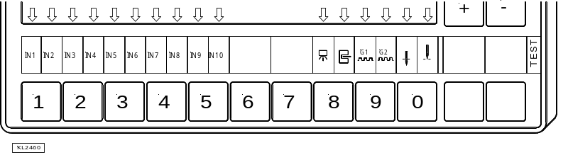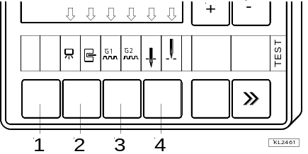

Note
If an input is active with open contact, the corresponding arrow lights up when the contact is open. If an input is active with closed contact, the corresponding arrow lights up when the contact is closed!

Outputs of control
- Select parameter 173.
- Select the desired output using the +/- keys.
- On the V810 control panel or on the built-in keypad in the control, the >> key is used to turn on the associated output, if it is connected and working.
- On the V820 control panel, instead of the >> key the key lower right, at the outer edge must be pressed.

Display example for Stitch condensinging output on the V810 control panel: | ➔
  2-34 oUt vr
Display example for Stitch condensinging output on the V820 control panel: | ➔
  2-34 oUt vr

Assignment of outputs
Display | Function / Output | on socket ST2
OUT VR | Stitch condensing | 34
OUT FL | Sewing foot lifting | 35
OUT 1 | M1 | 37
OUT 2 | M2 | 28
OUT 3 | M3 | 27
OUT 4 | M4 | 36
OUT 5 | M5 | 32
OUT 6 | M6 | 30
OUT 7 | M7 | 23
OUT 8 | M8 | 24
OUT 9 | M9 | 25
OUT 10 | M10 | 29
OUT 11 | M11 | 31
POS 1 | Position 1 | 20

Table of Machine Functions and Adapter Cords
Attention
Before switching functional sequences, detach cables from the inputs and outputs! It must be absolutely certain that for the functional sequence to be changed the machine provided has been installed! Then proceed with the setting using parameter 290!

Operating Elements and Socket Connectors

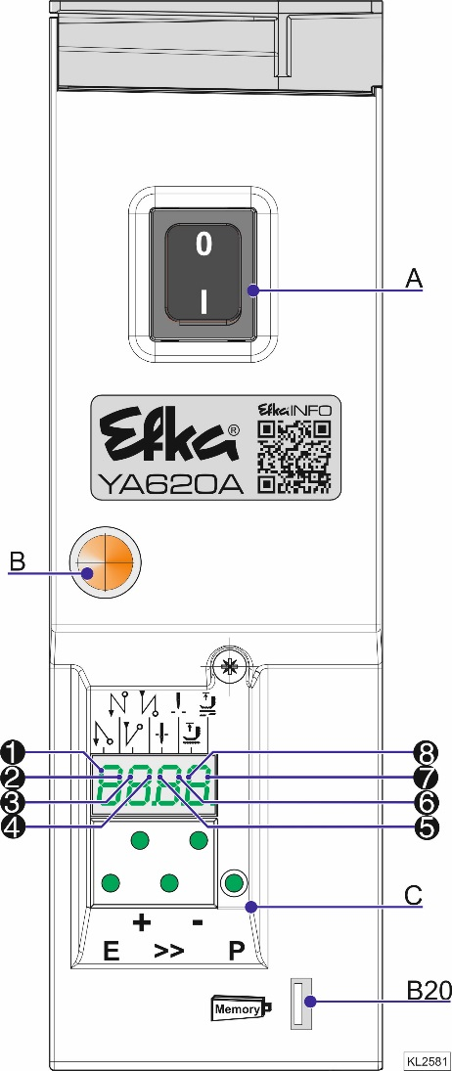
Positions of the Front Side
A | Power switch
B | Network control lights
C | Control panel (onboard module)  + Display (4-digit 7-segment display)
Key
P | Call or exit programming mode
E | Start Stitch condensing single / double / off  Enter key for modifications in the programming mode
+ | End Stitch condensing single / double / off  In the programming mode - increase of the value indicated
>> | Basic position 1 or 2  In programming mode as shift key
– | Automatic sewing foot lifting at stop in the seam On/Off  Automatic sewing foot lifting after thread trimming On/Off  In the programming mode - decrease of the value indicated
The upper vertical segments of the 4 digit 7 -segment display indicate the switching states of foot lifting and basic position.
1 | start Stitch condensing
2 | Double start Stitch condensing
3 | Single end Stitch condensing  Tape cutter at the start of the seam ON/OFF (mode 7)
4 | Double end Stitch condensing  Tape cutter at the seam end ON/OFF (mode 7)
5 | Basic position “needle position 1“
6 | Basic position “needle position 2“
7 | Automatic sewing foot lifting at stop in the seam
8 | Automatic sewing foot lifting after the thread trimming operation
Connector
B20 | USB Memory Stick

Positions of the rear side
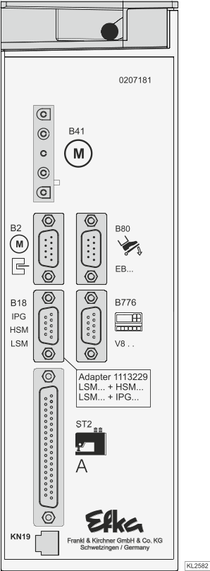

Connector
B2 | Commutation transmitter
B18 | Light barrier module LSM002  - Hall sensor module HSM001  - Pulse encoder IPG001  (Adapter cord 1113229 in case of multiple assignment)
B41 | Motor power supply
B80 | Actuator
ST2 | Socket for inputs and outputs  e. g. solenoids, solenoid valves, displays, keys and switches
B776 | V810/V820 Control Panel
KN19 | Knee switch

Connection Diagrams
Inputs switched to 0V

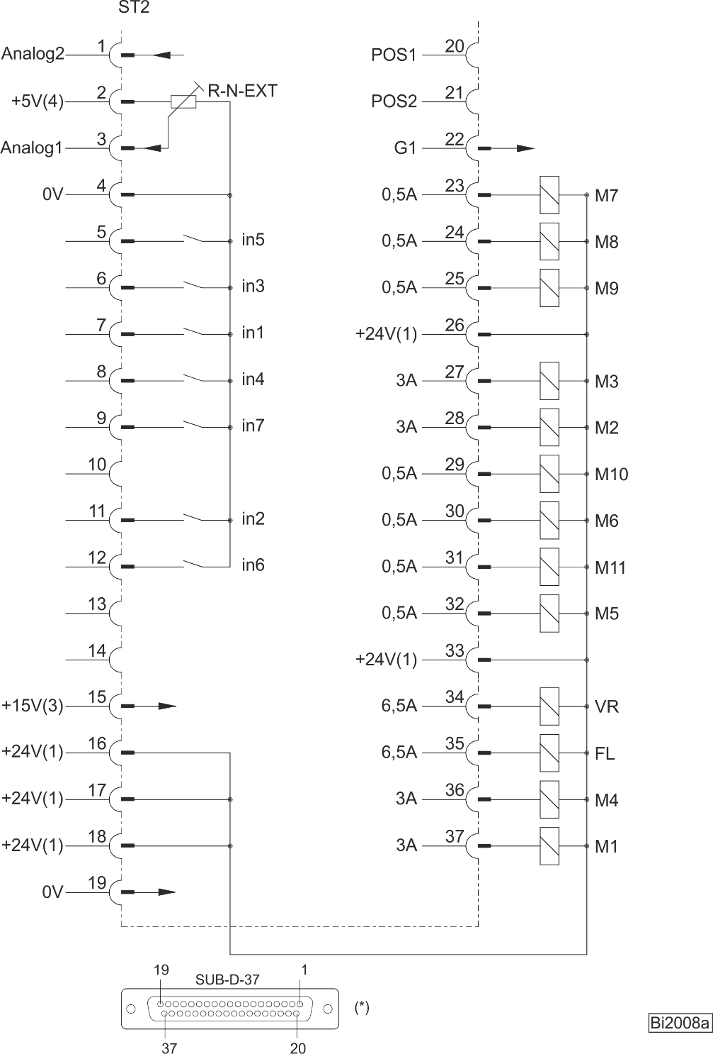

Attention
When connecting the outputs, ensure that a total power of 96VA constant load will not be exceeded!

in1 | Input 1 | R-N-EXT | Machine speed limitation by “select”-resistor at Analog1 | M4 | Output 4
in2 | Input 2 | VR | Stitch condensing | M5 | Output 5
in3 | Input 3 | POS1 | Position 1 | M6 | Output 6
in4 | Input 4 | POS2 | Position 2 | M7 | Output 7
in5 | Input 5 | FL | Sewing foot lifting
in6 | Input 6 | G1 | Generatorsignal | M8 | Output 8
in7 | Input 7 | M1 | Output 1 | M9 | Output 9
 |  | M2 | Output 2 | M10 | Output 10
 |  | M3 | Output 3 | M11 | Output 11

Inputs switched to +24 V

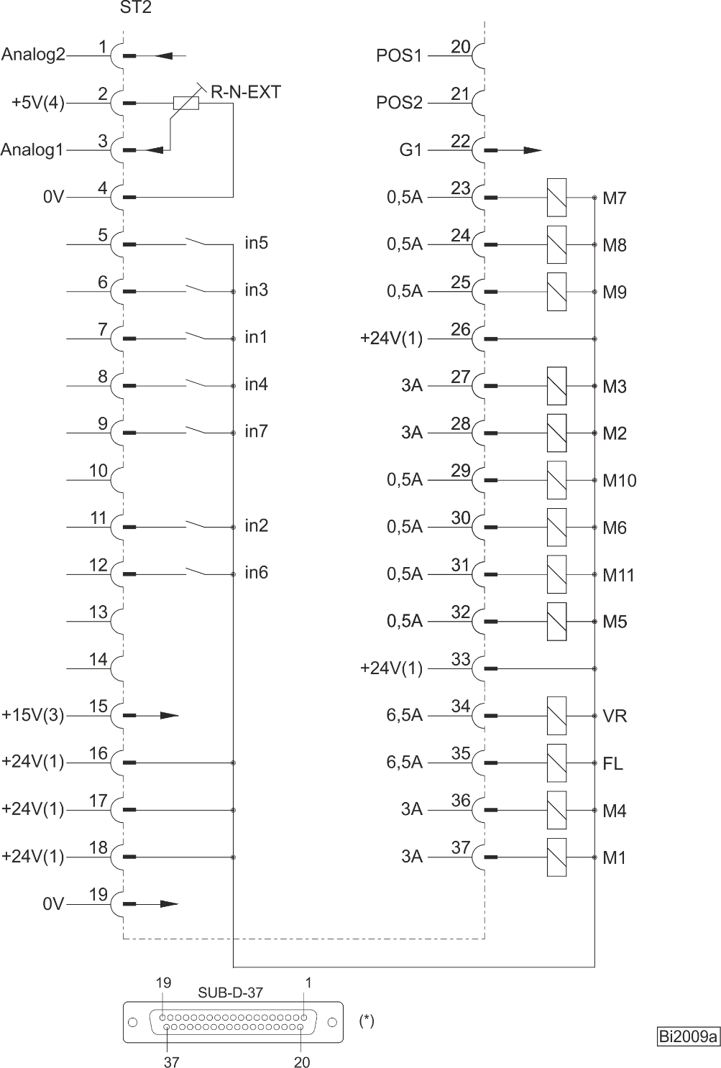

Attention
When connecting the outputs, ensure that a total power of 96VA constant load will not be exceeded!

- Nominal voltage +24 V, no-load voltage max. +30 V momentarily after power on
- Transistor output with open collector max. +40 V, I_{max} 10 mA
- Nominal voltage +15 V, I_{max} 30 mA
- Nominal voltage +5 V, I_{max} 20 mA
*) View: Front view of the control (component side) and/or rear view of the outgoing connecting cable

Connection of a HSM001 Hall sensor module or an IPG001 pulse encoder | Connection of a light barrier module  LSM002

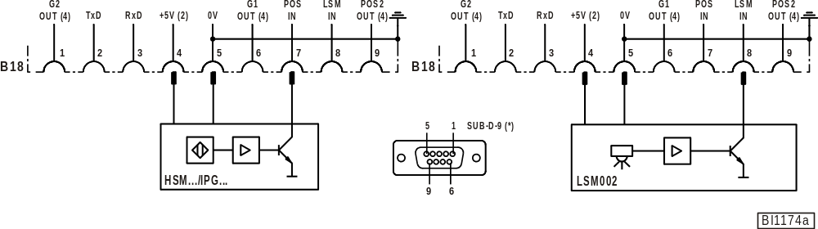
Adapter cord 1113229 in case of multiple assignment of socket B18!
POS2 OUT | Output for position 2 | LSM IN | Possibility of connecting a light barrier module to socket B18/8
POS IN | Input for positions (e. g. connection of a sensor) | LSM002 | Reflection light barrier module
G1/G2 OUT | Output of generator impulses | HSM001 | Hall sensor module
TXD/RXD | Serial transmission lines | IPG | Pulse encoder

If parameter 239 is set to >0, it is possible to operate a key at the input of the B18/8 connector.

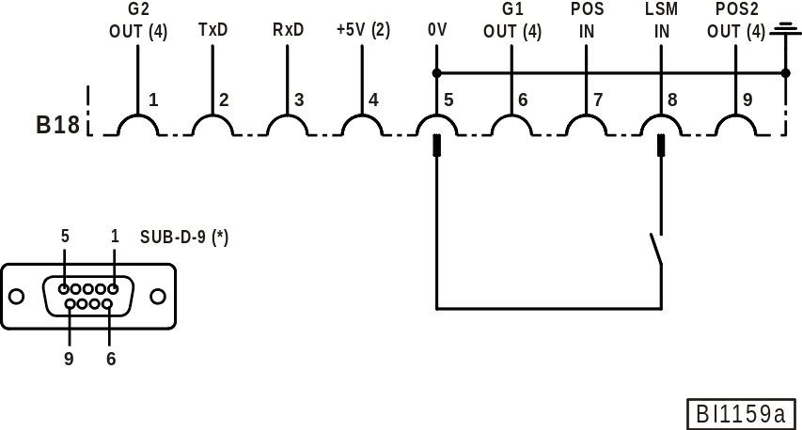

There is a supply voltage of +5 V on the B18/4 socket for external devices. This voltage can be switched
to +15 V using parameter 362.

- Nominal voltage +5V, I_{max} 100 mA (switchable to +15 V, I_{max} 100 mA)
- Logic level output +5 V, I_{max} 5 mA
*) View: Front view of the control (component side) and/or rear view of the outgoing connecting cable

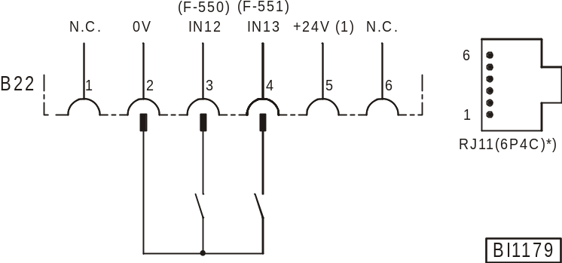

IN12 | Input 12, function programmable using parameter 550 | IN13 | Input 13, function programmable using parameter 551

Connecting the analogous actuator EB401

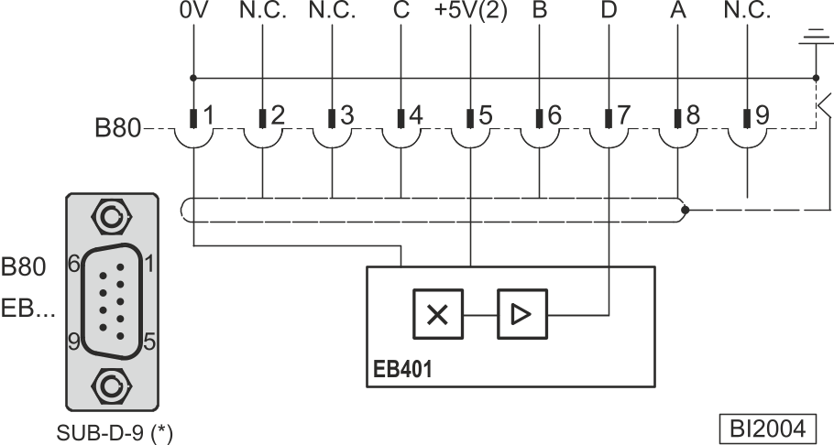

EB.. = Actuator

Code table for digital target value preset (grey code)

Pedal step ➔ | -2 | -1 | 0 | ½ | 1 | 2 | 3 | 4 | 5 | 6 | 7 | 8 | 9 | 10 | 11 | 12
Input A (B80/8) | L | L | H | H | H | L | L | H | H | L | L | H | H | L | L | H
Input B (B80/6) | L | H | H | L | L | L | H | H | H | H | L | L | L | L | H | H
Input C (B80/4) | H | H | H | H | L | L | L | L | L | L | L | L | H | H | H | H
Input D (B80/7) | H | H | H | H | H | H | H | H | L | L | L | L | L | L | L | L

Connection for frequency run

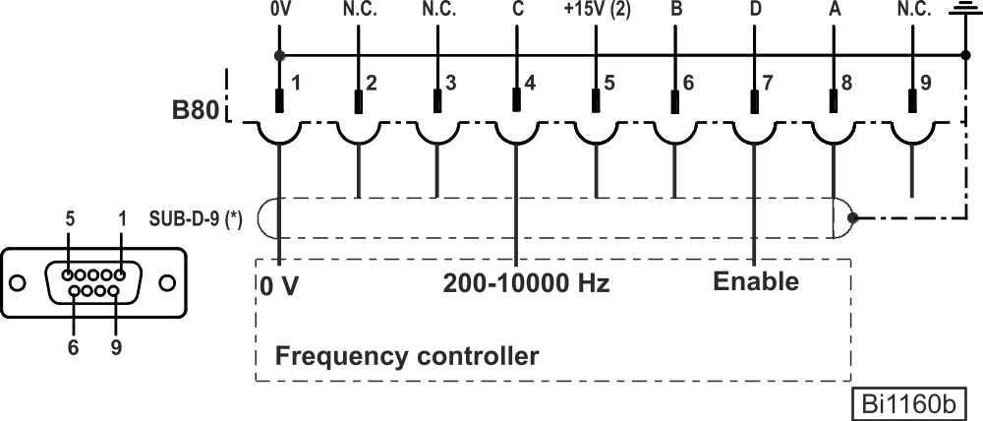

Connections: 0 V on Pin 1
Frequency output on Pin 4
Frequency controller output on Pin 7

In order to introduce motor running 0V must be applied to pin 7

Frequency rates: 0-5 V / 200-10000 Hz
Min. speed 50 min⁻¹
Max. speed F-111

Parameter F-396 =0 Frequency Off
F-396 =1 Frequency On

Plug B80 input signal

Pin8 "A" | Pin6 "B" | Pin4 "C" | Pin5 "D" | Motor state
X | X | X | Deactivated. | Stop
X | X | Frequency < 60 Hz | Activated (0V) | Stop
X | X | Frequency > 60 Hz | Activated (0V) | Running
X | X | Frequency > 60 Hz | Deactivated. | Stop
0 V | 0 V | X | Deactivated. | Trimmer

- Nominal voltage +24 V, no-load voltage max. +30 V momentarily after power on
- Nominal voltage +5 V, I_{max} 20 mA
*) View: Front view of the control (component side) and/or rear view of the outgoing connecting cable

Timing Diagrams
Mode 0-5 (chainstitch)
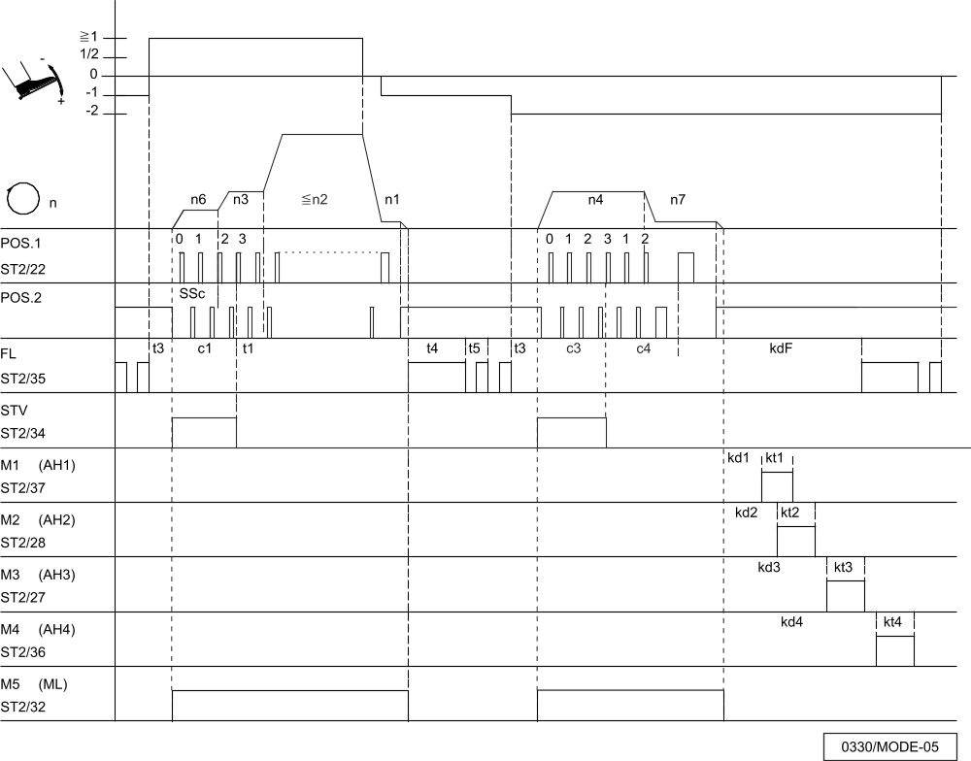

Mark | Function |  | Parameters | Control | V810 | V820
FAm  SSt | Mode 5  Softstart  Start stitch condensing  End stitch condensing | On  On | 290 =5  134 =1 | Key E  Key + | Key 1  Key 2 | Key 1  Key 4
n1  n2  n3  n4  n6  n7 | Positioning speed  Maximum speed  Start stitch condensing speed  End stitch condensing speed  Softstart speed  Trimming speed |  | 110  111  112  113  115  116
c1  c3  c4  SSc  t1  t3  t4  t5  kdF  kd1-kd4  kt1-kt4 | Stitch counting of start stitch condensing  Stitch counting of end stitch condensing  Stitch counting at the seam end without stitch regulator  Softstart stitches  Delay until speed release after start Stitch condensing  Start delay from lifted sewing foot  Full power of sewing foot lifting  Pulsing of sewing foot lifting  Switch-on delay of sewing foot lifting  Delay times of outputs M1...M4  ON periods of outputs M1...M4 |  | 001  002  003  100  200  202  203  204  288  280/2/4/6  281/3/5/7

Mode 40 (Overlock)
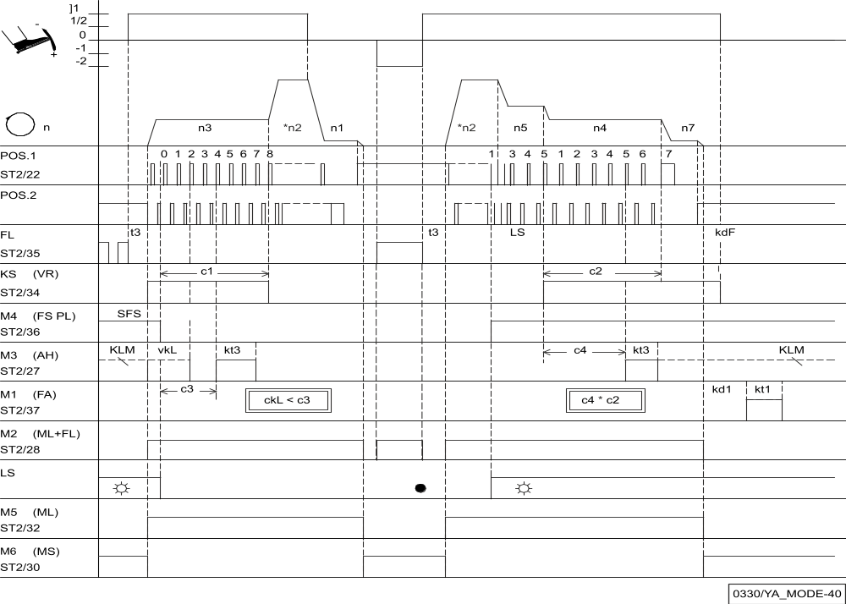

Mark | Function | Parameters | Control | V810 | V820
FAm  LS  UoS  -Pd  SPO  tFS  LSS  kSA  kSE  mhE  PLS  kSL  USS | Mode 7  Counts c1, c2, c3 and c4  Sewing foot lifting at the seam end  Light barrier  Sequence “overlock mode with stop”  Function “pedal in pos. –2” blocked  Chain suction at the seam end until pedal in pos. 0 (neutral)  Beginning of thread tension release at the start of the seam  Start blockage with light barrier uncovered  Stitch counting at the start of the seam at fixed speed n3  Stitch counting at the seam end at fixed speed n4  Seam end after count c2  Speed n5 after light barrier sensing  Chain suction On after light barrier compensating stitches  Tape cutter function | 290 = 7  On  On  009 = 1  018 = 0  019 = 2  022 = 1  025 = 0  132 = 0  143 = 0  144 = 0  191 = 1  192 = 0  193 = 0  232 = 0 | Key E/+  Key - | Key 1/2  Key 3 | Key 1/4  Key 6
n1  n2  n3  n4  n5  n7 | Positioning speed  Maximum speed  Speed for start counting  Speed for end counting  Speed after light barrier sensing  Trimming speed | 110  111  112  113  114  116
c2  c1  c3  c4  LS  ckL  SFS  kd1/kd  kt1  kt3  kdF | End counting for chain suction  Start counting for chain suction  Start counting for tape cutter  End counting for tape cutter  Light barrier compensating stitches  Run-out stitches clamp at the start of the seam  Stitches from light barrier uncovered until end FSPL-E  Delay times of outputs M1/M  ON periods of outputs M1/M2  ON period of tape cutter  Switch-on delay of sewing foot lifting | 000  001  002  003  004  021  157  280/282  281  285  288

Operator Level
Note
The preset values indicated apply to mode 0 (Parameter 290 = 0).
For preset values applicable to other modes see table in chapter 11.1 »Preset Values Depending on Mode«.

Parameters | Designation |  | Unit | Max | Min | Preset | Ind.
000 c2 | - Number of stitches of start stitch condensing without stitch regulator |  | Stitches | 254 | 0 | 2
001 c1 | - Number of stitches of start stitch condensing with stitch regulator |  | Stitches | 254 | 0 | 4
002 c3 | - Number of stitches of end stitch condensing with stitch regulator |  | Stitches | 254 | 0 | 2
003 c4 | - Number of stitches of end stitch condensing without stitch regulator |  | Stitches | 254 | 0 | 2
004 LS | Light barrier compensating stitches |  | Stitches | 254 | 0 | 7
005 LSF | Number of stitches of the light barrier filter for knitted fabrics |  | Stitches | 254 | 0 | 1
006 LSn | Number of photoelectric seams |  |  | 15 | 1 | 1
007 Stc | Number of stitches for the seam with stitch counting |  | Stitches | 999 | 0 | 20
008 -F | A parameter from the technician level is assigned to key 9 on the V820 control panel  - Softstart On/Off  2-9= Reserved |  |  | 9 | 1 | 1
009 LS | Light barrier On/Off |  |  | 1 | 0 | 0
013 FA | Thread trimmer On/Off |  |  | 1 | 0 | 0
014 Fw | Thread wiper On/Off |  |  | 1 | 0 | 0
015 StS | Stitch counting On/Off |  |  | 1 | 0 | 0
017 SAb | Stop for tape cutting at the seam end On/Off  (Function only when overlock mode is active). |  |  | 1 | 0 | 0
018 UoS | - Sequence “overlock mode with stop”  - Sequence “overlock mode without automatic stop. When the command “run” is given, the drive runs at the pre-selected speed. With pedal in pos. 0 or light barrier covered, the program switches to the next start of a seam without issuing signals M1/M2.  - As with setting “1”. But with pedal in pos. 0 signals M1/M2 will be issued, and the program switches to the next start of a seam.  - As with setting “1”. But with pedal -2 signals M1/M2 will be issued, and the program switches to the next start of a seam. Intermediate stop and sewing foot lifting with pedal in pedal -1 is possible.  - If the light barrier is covered during the end count for chain suction, the program switches immediately to the next start of a seam. If the end count has been completed and the light barrier remains uncovered, the drive stops.  - Tape cutting at the start of the seam with stop |  |  | 5 | 0 | 0
019 -Pd | - Pedal in pos. -1 blocked in the seam. But with pedal in pos.  -2 sewing foot lifting is possible in the seam (function active whenever the light barrier is On)  - With pedal in pos. -1 sewing foot lifting is blocked in the seam.  - Pedal in pos. –2, thread trimming disabled. (Function only if parameter 009 = 1)  - Pedal in pos. –1 and –2 enabled in the seam.  - Pedal -1 and -2 locked in the seam (function only when parameter 009 =1)  - Start seam end by with pedal -1  - pedal full heel back |  |  | 6 | 0 | 3
020 kLm | Clamp at the seam end On/Off |  |  | 1 | 0 | 0
021 ckL | Run-out stitches clamp at the start of the seam | Stitches |  | 254 | 0 | 2
022 SPO | - chain suction up to end of count c2  - Chain suction at the end oft he seam till pedal 0  - chain suction until motor stop-  delay (parameter 237) |  |  | 2 | 0 | 0
023 AFL | Automatic sewing foot lifting with pedal forward at the seam end, if light barrier or stitch counting is On.  - Automatic foot lifting off  - Automatic foot lifting On |  |  | 1 | 0 | 1

024 FSP | Coupled thread tension release and sewing foot lifting.  The function can be activated only with a thread trimmer that depends on the angle.  - No coupling  - Coupled thread tension release and sewing foot at the seam end with thread trimmer off  - Coupled thread tension release and sewing foot in the seam and at the seam end with thread trimmer off  - Coupled thread tension release and sewing foot always effective |  | 3 |  | 0 | 0
025 tFS | Start counter (Pa. 157) for thread tension  lift at seam end  - Start counter on seam beginn  - Start counter by light barrier dark |  | 1 |  | 0 | 1
026 APd | Characteristic of the "analog pedal"  - Analog function off  - 12-level, like previous pedal function  - continuously variable  - 24-level  - 60-level  - 48-level  - 48 level / standing operation (SOP; foot control 304)i  7-11=Reserved |  |  | 11 | 0 | 4
027 plu | Area for setting + 1/2 of the analog pedal in percent |  |  | 80 | 10 | 30
030 rfw | Bobbin thread monitor  - Off  - Active with stop  - Active without stop  - Active with stop and start blockage after thread trimming  - As 1, but with display of remaining stitches  - As 2, but with display of remaining stitches  - As 3, but with display of remaining stitches |  |  | 6 | 0 | B
031 cfw | Number of stitches for bobbin thread monitor.  (The 3-digit value must be multiplied by 100). |  |  | 255 | 0 | B
037 Tu | Monitoring for FF1 signal in sec |  |  | 60 | 0 | 0
038 1FH | Coupling with the 2nd thread tension release AFF1  - Off  - Coupling with FA  - Coupling with HP  - Coupling with FA and HP |  |  | 3 | 0 | 0
039 1FL | Coupling with foot lifting with the 2nd thread tension AFF1  - Off  - Coupling with foot lifting in the seam  - Coupling with foot lifting at the seam end  - Coupling with foot lifting in the seam and at the seam end |  |  | 3 | 0 | 0
040 3FB | Mode FlipFlop3  - Off  - Switched off when the foot is lifted  - Switched off during a reverse backtack  - Switched off when the foot is lifted or locked. |  |  | 3 | 0 | 0
041 EZP | Special pedal function Single stitch / Full stitch  - Function Off  - Single stitch (assuming needle up to needle down). Afterwards alas a complete hand wheel rotation in speed n9)  - Full stitch (a complete hand wheel rotation in speed n9)  - Speed limitation up to F-042 |  |  | 3 | 0 | 0
042 GrP | Pedal travel forwards for detection of the special pedal function | % |  | 100 | 0 | 40
049 KML | Clutch motor running (Kopplung MotorRunnig) signal (F-290=7)  =0 OFF  =1 clutch with pedal Mi1 & pedal Mi2 in the seam  =2 clutch with pedal Mi1 & pedal Mi2 outside of the seam  =3 clutch with pedal Mi1 & pedal Mi2 in and outside of the seam  4-9= Reserved |  |  | 9 |  | 0 | 0
051 dPd | Time for detection of the special pedal function | ms |  | 2550 | 0 | 100
082 DDr | Suck stitches to waste | Stitches |  | 254 | 0 | 25 | D
083 tDr | Time sucking waste | ms |  | 5000 | 0 | 0 | D
084 Mle | Stitches for motor ECO On | Stitches |  | 254 | 0 | 5
085 Mla | Stitches for motor ECO runs down | Stitches |  | 254 | 0 | 5

Technical level (Code no. 1907)
Parameters | Designation | Unit |  | Max | Min | Preset | Ind.
100 SSc | Number of softstart stitches | Stitches |  | 254 | 0 | 2
110 n1 | Positioning speed for threading (mode 66) | RPM |  | 390 | 70 | 200
111 n2 | Upper limit setting range of the maximum speed | RPM |  | 9900 | n2_ | 5000
112 n3 | Start Stitch condensinging speed | RPM |  | 9900 | 200 | 1200
113 n4 | End Stitch condensinging speed | RPM |  | 9900 | 200 | 1200
114 n5 | Speed after light barrier sensing | RPM |  | 9900 | 200 | 1200
115 n6 | Softstart speed | RPM |  | 9900 | 70 | 500
116 n7 | Trimming speed | RPM |  | 700 | 70 | 200
117 n10 | High lift for walking speed limitation | RPM |  | 9900 | 400 | 1000
118 n12 | Automatic speed for stitch counting | RPM |  | 9900 | 400 | 3500
119 nSt | Speed stage graduation  1 = Linear  2 = Slightly progressive  3 = Highly progressive |  |  | 3 | 1
121 n2 | Lower limit setting range of the maximum speed | RPM |  | n2_ | 200 | 400
122 n9 | Limited speed n9 | RPM |  | 9900 | 200 | 2000
123 n11 | Limited speed n11 | RPM |  | 9900 | 200 | 2500
127 AkS | Acoustic signal by V8xx ON/OFF |  |  | 1 | 0 | 0 | 1
128 ASd | Start delay, when command “start” is given by covering the light barrier (see parameter 129) | ms |  | 2000 | 0 | 0
129 ALS | Machine start by covering the light barrier (only in conjunction with parameter 132 = 1)  - Function Off  - Light barrier covered ➔ pedal forward (>1) ➔machine run pedal controlled.  - Pedal forward (>1) ➔ light barrier covered machine run ➔ pedal controlled.  - Light barrier covered ➔ machine run at automatic speed n12 (without pedal)  - Pedal forward (>1) ➔ light barrier covered machine run ➔pedal controlled.  Attention! If 129 = 3, the machine starts immediately after covering the light barrier without influence by the pedal! It can be stopped only by uncovering the light barrier or by machine run blockage!  If machine run blockage is disabled, the machine starts immediately even if the light barrier is still covered! |  |  | 4 | 0 | 0
130 LSF | Light barrier filter for knitted fabrics |  |  | 1 | 0 | 0
131 LSd | - Light barrier sensing “covered”  - Light barrier sensing uncovered |  |  | 1 | 0 | 1
132 LSS | - Machine start possible with light barrier uncovered or covered.  - Machine start blocked with light barrier uncovered if parameter 131 = 1.Machine start blocked with light barrier covered, |  |  | 1 | 0 | 1
133 LSE | Thread trimming operation, when completing the seam after light barrier sensing On/Off |  |  | 1 | 0 | 1
134 SSt | Softstart On/Off |  |  | 1 | 0 | 0
139 nIS | Display of machine speed On/Off |  | 1 |  | 0 | 0
140 dnE | Delay of seam end with pedal in pos. -2 | ms | 2550 |  | 0 | 0
141 SGn | Speed status for the seam with stitch counting  - Speed controllable by the pedal up to the set maximum speed (Parameter 111)  - Fixed speed (Parameter 118) without influence by the pedal (machine stop by pressing the pedal to the basic position)  - Limited speed controllable by the pedal up to the set limit (Parameter 118)  - At fixed speed (Parameter 118) can be interrupted by full heelback -2  - At fixed speed (Parameter 110) can be interrupted by full heelback -2 |  | 4 |  | 0 | 0

142 SFn | Speed status for the free seam and for the seam with light barrier  - Speed controllable by the pedal up to the set maximum speed (Parameter 111)  - Fixed speed (Parameter 118) without influence by the pedal (machine stop by pressing the pedal to the basic position)  - Limited speed controllable by the pedal up to the set limit (Parameter 118)  - At fixed speed (Parameter 118) can be interrupted by full heelback (only for seams with light barrier). |  | 3 | 0 | 0
143 kSA | Stitch counting at the start of the seam (e. g. chain suction)  - Speed controllable by the pedal up to the set maximum speed (Parameter 111)  - Fixed speed (Parameter 112) without influence by the pedal (machine stop by pressing the pedal to the basic position)  - Limited speed controllable by the pedal up to the set limit (Parameter 112)  - At fixed speed (Parameter 112), can be suspended or interrupted depending on the setting of parameter 019. |  | 3 | 0 | 0
144 kSE | Stitch counting at the seam end (e. g. chain suction)  - Speed controllable by the pedal up to the set maximum speed (Parameter 111).  - Fixed speed (Parameter 113) without influence by the pedal (machine stop by pressing the pedal to the basic position).  - Limited speed controllable by the pedal up to the set limit (Parameter 113)  - At fixed speed (Parameter 113), can be suspended or interrupted depending on the setting of parameter 019. |  | 3 | 0 | 0
153 brt | Braking power at machine standstill |  | 50 | 0 | 15
154 | Combination of output signal and foot lift  0 = No combination  1 = Combination of footlift and chain suction  2 = Combination of footlift and chain suction |  | 2
155 LSG | Mode signal run  - Signal Off.  - Signal run On.  - Signal “run” enabled when the speed is >3000 RPM.  - Signal with pedal <> 0.  - Signal enabled only after motor synchronization (one rotation at positioning speed after power On).  - Motor runs Eco with setting F-84 and F-85  - Motor runs the same as chain suction at the seam start / end with counter F-084 and F-085  - The same as 6, however chain suction at the start of the seam can be interrupted and with switch-off delay F-156  - For BAF bottem hem |  | 8 | 0 | 1
156 t05 | Switch-off delay for the signal “run” or signal with pedal in pos. 0 (neutral) | ms | 2550 | 0 | 0
157 SFS | Acoustic signal stitches until thread tension ventilation Off after light barrier dark at the beginning of the seam  (only mode 7) | stitches | 254 | 0 | 0
161 drE | Direction of motor rotation  - Clockwise rotation  - Counterclockwise rotation |  | 1 | 0 | 1
172 Sr3 | Display on the control:  Pos. 1 to 1A (LED segment 5 lights up)  Pos. 2 to 2A (LED segment 6 lights up)
172 Sr3 | Display on the V810 control panel:  Pos. 1 to 1A(left-hand arrow above key 4 On)  Pos. 2 to 2A(right-hand arrow above key 4 On)
172 Sr3 | Display on the V820 control panel:  Pos. 1 to 1A(left-hand arrow above key 7 On)  Pos. 2 to 2A(right-hand arrow above key 7 On)

173 Sr4 | Testing of signal inputs and outputs | OFF
 | Inputs
 | By actuating the switches connected to the control, the function of these switches is checked and displayed on the control. With the switch open, OFF appears (only in the control panel of the control) and with the switch closed, the corresponding input in1...in7, i11 (LSM), i12, i13 appears (on the V810/820/850, also the number of the connector socket and pin).
 | Outputs
- Select the desired output using the +/- keys.
- With the button >> the corresponding output is switched on, as long as it is connected and functional.
Output | Socket
Stitch condensinging | ST2/34
Sewing foot lifting | ST2/35
M1 | ST2/37
M2 | ST2/28
M3 | ST2/27
M4 | ST2/36
M5 | ST2/32
M6 | ST2/30
M7 | ST2/23
M8 | ST2/24
M9 | ST2/25
M10 | ST2/29
M11 | ST2/31

176 Sr6 | Service routine for total operating hours display.  The process is as with display example of parameter 177.
177 Sr7 | Service routine for display of hours since the last service.
 | Display example for the operator control panel:
 | Press the E key | ➔ | Display |  | Sr7=
 | Press the >> key | ➔ | Display |  | h t
 | Press the E key | ➔ | Display |  | 0000
 | Press the >> key | ➔ | Display |  | h h
 | Press the E key | ➔ | Display |  | 0000
 | Press the E key | ➔ | Display |  | Min
 | Press the E key | ➔ | Display |  | 00
 | Press the E key | ➔ | Display |  | SEc
 | Press the E key | ➔ | Display |  | 00
 | Press the E key | ➔ | Display |  | MS
 | Press the E key | ➔ | Display |  | 000
 | Press the E key | ➔ | Display |  | rES
 | Press the E key again to restart routine, or press the P key twice to return to operational status
 | Display example for the V810 control panel:
 | Press the E key | ➔ | Display |  | Sr7 [°]
 | Press the >> key | ➔ | Display |  | hoUr
 | Press the E key | ➔ | Display |  | 000000
 | Press the E key | ➔ | Display |  | Min
 | Press the E key | ➔ | Display |  | 00
 | Press the E key | ➔ | Display |  | SEc
 | Press the E key | ➔ | Display |  | 00
 | Press the E key | ➔ | Display |  | MSEc
 | Press the E key | ➔ | Display |  | 000
 | Press the E key | ➔ | Display |  | rES F2
 | Press the P key twice | ➔ | Display e.g. |  | YA620A
 | Display example for the V820 control panel:
 | Press the E key | ➔ | Display |  | F-177 |  | Sr7 [°]
 | Press the >> key | ➔ | Display |  | hoUr |  | 000000
 | Press the E key | ➔ | Display |  | Min |  | 00
 | Press the E key | ➔ | Display |  | SEc |  | 00
 | Press the E key | ➔ | Display |  | MSEc |  | 000
 | Press the E key | ➔ | Display |  | rES |  | F2
 | Press the P key twice | ➔ | Display e.g. |  | YA620A
179 Sr5 | Display of control program number with index and more identification numbers. The data is displayed in sequence by keystroke.
 | Display example for the operator control panel:
 | Press the E key | ➔ | Display |  |  | Sr5=
 | Press the >> key | ➔ | Display e.g. |  |  | 5080 |  | (Prog. No.)
 | Press the E key | ➔ | Display e.g. |  |  | A |  | (Index)
 | Press the E key | ➔ | Display e.g. |  |  | 06 |  | (Year)
 | Press the E key | ➔ | Display e.g. |  |  | 10 |  | (Month)
 | Press the E key | ➔ | Display e.g. |  |  | 24 |  | (Day)
 | Press the E key | ➔ | Display e.g. |  |  | 16 |  | (Hour)
 | Press the E key | ➔ | Display e.g. |  |  | --
 | Press the E key | ➔ | Display e.g. |  |  | ----
 | Press the E key again to restart routine, or press the P key twice to return to operational status

Parameters |  | Designation |  |  |  | Unit |  | Max |  |  | Min | Preset |  | Ind.
 |  | Display example for the V810 control panel:
 |  | Press the E key | ➔ | Display | Sr [°]
 |  | Press the >> key | ➔ | Display e.g. | 5080
 |  | Press the E key | ➔ | Display e.g. | 010823
 |  | Press the E key | ➔ | Display e.g. | 15
 |  | Press the E key | ➔ | Display e.g. | 1F68
 |  | Press the P key twice | ➔ | Display | YA620A
 |  | Display example for the V820 control panel:
 |  | Press the E key | ➔ | Display | F-179 |  | Sr5 [°]
 |  | Press the >> key | ➔ | Display e.g. | PrG |  | 5080
 |  | Press the E key | ➔ | Display e.g. | dAt |  | 01082315
 |  | Press the E key | ➔ | Display e.g. | Chk |  | 1F68
 |  | Press the E key | ➔ | Display e.g. | 132650210015
 |  | Press the E key | ➔ | Display e.g. | Skn |  | 01047543
 |  | Press the P key twice | ➔ | Display | 4000 |  | YA620A
181 drd |  | Delay reverse rotation |  |  |  |  |  | ms |  | 990 | 0 | 10
182 Frd |  | Reverse rotation ON/OFF |  |  |  |  |  |  |  | 1 | 0 | 0
184 c6 |  | Numbers of tracking stitches when unlocking the chain |  |  |  |  |  | Stitches |  | 254 | 0 | 20
190 mEk |  | Function unlocking the chain in mode 5, 6, and 7  (parameter 290)  - unlocking the chain OFF  - unlocking the chain manually (by pedal -2 without chop at the end of the seam)  - unlocking the chain automatically  - with light barrier or  - pedal -2 (parameter 019) without chop at the end of the seam.  - unlocking the chain automatically  - with light barrier or  - pedal -2 (parameter 019) with chop and trailing stitches (parameter 184) at the end of the seam, then unlocking the chain (only if parameter 290 = 7)  - unlocking the chain only by pedal -2.  Not unlocking the chain at the end oft the seam with light barrier,chop and trailing stitches |  |  |  |  |  | 4 |  | 0 | 1
191 mhE |  | Seam end at Overlock mode by endcounter c2 or c4  - seam end after counter c4 – Cutter  - seam end after counter c2 – Chain suction |  |  |  |  |  | 1 |  | 0 | 0
192 PLS |  | Speed of the light barrier compensating stitches  - Speed n5 after light barrier sensing  - Speed pedal controlled |  |  |  |  |  | 1 | 0 |  | 0
193 kSL |  | Turn on the signal chain suction and the  0= Thread tension release  1= Thread tension releas and chain suction after expiry of the light  barrier compensation stitches |  |  |  |  |  | 1 | 0 |  | 0
199 FSn |  | Thread tension release at the seam end On/Off.  - Thread tension release Off at the seam end for pedal in pos. 0.  - Thread tension release On at the seam end for pedal in pos. 0.  - Thread tension release at the seam end and after power on and pedal in position 0 On. |  |  |  |  |  | 2 | 0 |  | 0
200 t1 | Delay until speed release after start Stitch condensing |  |  |  |  | ms |  | 500 | 0 |  | 100
201 t2 | Sewing foot switch-on delay after thread wiper with half heelback |  |  |  |  | ms |  | 2550 | 20 |  | 80
202 t3 | Start delay after disabling the sewing foot lifting signal |  |  |  |  | ms |  | 500 | 0 |  | 50
203 t4 | Time of full power of sewing foot lifting |  |  |  |  | ms |  | 600 | 0 |  | 500
204 t5 | Holding power for sewing foot lifting 1...100%  1% ➔ low holding power  100% ➔ high holding power |  |  |  |  | % |  | 100 | 1 |  | 40
205 t6 | Thread wiper time |  |  |  |  | ms |  | 2550 | 0 |  | 120
206 t7 | Delay from end of thread wiper until sewing foot lifting On |  |  |  |  | ms |  | 800 | 0 |  | 40
207 br1 | Braking effect when varying the preset value ≤ 4 stages (indicated values only with transmission ratio 1:1) |  |  |  |  |  |  | 55 | 1 |  | 15
208 br2 | Braking effect when varying the preset value ≥ 5 stages (indicated values only with transmission ratio 1:1) |  |  |  |  |  |  | 55 | 1 |  | 20

209 dFw |  | Thread wiper switch-on delay | ms | 2550 | 0 | 0
211 tFL |  | Sewing foot lifting switch-on delay with thread wiper off | ms | 500 | 0 | 60
219 br3 |  | Braking ramp for n < 350 when drive stopped |  | 55 | 1 | 4
220 ALF |  | Accelerating power of the drive (indicated values only with transmission ratio 1:1) |  | 55 | 1 | 35
225 br4 |  | Setting of the braking edge for the photoelectric barrier and the running lock (values only for translation 1:1) |  | 55 | 1 | 20
229 dP2 |  | Delay of heelback (-2) | ms | 2000 | 0 | 0
232 USS |  | Überwendlich mit schneller Schere Ein/Aus |  | 1 | 0 | 0
233 c |  | Einschaltverzögerung der Fadenspannungslüftung | Stiche | 254 | 0
234 Pd0 |  | Wiederanlauf nach Laufsperre über Pedal 0-Lage |  | 1 | 0
236 FLP |  | 0 = Fl always permitted  1 = FI only permitted in position 2  2 = FI after cutting stored pedal plus ½ lifts storing, pedal minus 1 switches stored FI on.  3 = Storage for standing actuation FBxxx  4 = Fl generally deactivated  5 = Stored foot lifting at the seam end can be deactivated with pedal plus ½ and pedal minus 1. |  | 5 | 0 | 0 | B
237 tkS |  | Delay vor chain suction at the end oft he seam, if parameter 022 = 2. | ms | 2550 | 0 | 0
238 EnP |  | Software debouncing for all inputs:  - without debouncing  - with debouncing |  | 1 | 0 | 1
239 FEL |  | Selection of the input function on socket B18/8  - Light barrier function, if 009 =1  All other functions as with parameter 240. |  | 138 | 0 | 0
***) | The 4-digit value displayed must be multiplied by 10.

Supplier level (Code No. 3112)
Parameters | Designation | Unit |  | Max |  | Min |  | Preset | Ind.
240 in1 | Selection of the input functions on socket ST2/7 for input 1  - No function  - Needle up/down  - Needle up  - Single stitch (basting stitch)  - Full stitch  - Needle to position 2  - Machine run blockage effective with open contact  - Machine run blockage effective with closed contact  - Machine run blockage unpositioned effective with open contact  - Machine run blockage unpositioned effective with closed contact  - Automatic speed n12 without pedal (N.O. contact)  - Limited speed n12 pedal controlled  - Sewing foot lifting with pedal in position 0 (neutral)  - No function  - Needle to position 2 (see instruction manual)  - External light barrier (according to setting of parameter 131)  - Speed n9 pedal controlled  - Automatic speed n9 can be suspended by pressing the pedal to pos. 0 (neutral)  - Speed n12 pedal controlled (break contact)  - Automatic speed n12 without pedal (break contact [N.C.])  43 = No function  44 = Seam end the same as with pedal 2  45..81 = No function  102 = AFF2 ex. switch stitch length  110 = Machine run blockage in Pos. 2 at the seam end open  111 – 118 No function  119 – EZH Knee Switch  120 – 138 No function |  |  |  | 138 |  | 0 | 0
241 in2 | Selection of input function on socket ST2/11 for input 2  - No function  All other functions of the keys as with parameter 240 |  |  |  | 138 |  | 0 | 0
242 in3 | Selection of input function on socket ST2/6 for input 3  - No function  All other functions of the keys as with parameter 240 |  |  |  | 138 |  | 0 | 0
243 in4 | Selection of input function on socket ST2/8 for input 4  - No function  All other functions of the keys as with parameter 240 |  |  |  | 138 |  | 0 | 0
244 in5 | Selection of input function on socket ST2/5 for input 5  - No function  All other functions of the keys as with parameter 240 |  |  |  | 138 |  | 0 | 0
245 in6 | Selection of input function on socket ST2/12 for input 6  - No function  All other functions of the keys as with parameter 240 |  |  |  | 138 |  | 0 | 0
246 in7 | Selection of input function on socket ST2/9 for input 7  - No function  All other functions of the keys as with parameter 240 |  |  |  | 138 |  | 0 | 0
250 iFA | Thread trimmer activation angle |  | Degrees |  | 359 |  | 0 | 180
251 FSA | Switch-off delay of thread tension release |  | ms |  | 990 |  | 0 | 50
252 FSE | Switch-on delay angle of thread tension release |  | Degrees |  | 359 |  | 0 | 0
253 tFA | Stopping time for thread trimming |  | ms |  | 500 |  | 0 | 70
254 EF- | Upper limit (Pa.204) clocking the sewing foot lifting switch on period (ED) 1...100 % |  | % |  | 100 |  | 1 | 100
267 Abc | Overlock mode: Cancellation of the initial count and initiate the seam end by light barrier bright |  |  |  | 1 |  | 0 | 0

268 SEL | Machine speed limitation by „select“-resistor at Analog1  0= speed limitation inactive  1= speed limitation active  Resistance: rotational speed:  shorted connection 3000rpm  100R 8500rpm  150R 8000rpm  220R 7500rpm  300R 7000rpm  390R 6500rpm  520R 6000rpm  680R 5500rpm  920R 5000rpm  1220R 4500rpm  1680R 4200rpm  2500R 4000rpm  open connection 2000rpm (no resistor installed) |  | 1 | 0 | 0
269 PSv | Positioning shift | Incr. | 255 | 0 | 10
270 PGm | Mode of a position sensor with a normally closed function (N.C.). |  | 7 | 0 | 0
- The positions are generated using the transmitter incorporated in
the motor and can be set using parameter 171 *)
- The positions are generated using the external position encoder

272 trr | Transmission ratio between motor shaft and machine shaft (calculation formula see instruction manual!)  The transmission ratio should be determined and indicated as precisely as possible! |  |  | 40000 | 150 | 1000
280 kd1 | Delay time output M1 | ms | 5000 |  | 0 | 0
281 kt1 | ON period output M1 | ms | 5000 |  | 0 | 100
282 kd2 | Delay time output M2 | ms | 5000 |  | 0 | 100
283 kt2 | ON period output M2 | ms | 5000 |  | 0 | 100
284 kd3 | Delay time output M3 | ms | 5000 |  | 0 | 200
285 kt3 | ON period output M3 | ms | 5000 |  | 0 | 100
286 kd4 | Delay time output M4 | ms | 5000 |  | 0 | 300
287 kt4 | ON period output M4 | ms | 5000 |  | 0 | 100
288 kdF | Delay time until sewing foot On | ms | 5000 |  | 0 | 380
290 FAm | Value mode  - Yamato VC, VE, VF, VG  - Yamato VC, VE, VF, VG  - Yamato VC, VE, VF, VG  - Yamato VC, VE, VF, VG  - Yamato VC, VE, VF, VG  - Yamato VC, VE, VF, VG  - Yamato VC, VE, VF, VG  - Yamato VC, VE, VF, VG  - Yamato VC, VE, VF, VG  - Yamato VC, VE, VF, VG  - Yamato VC, VE, VF, VG  - Yamato VC, VE, VF, VG  - Yamato FD | UT | STA/WIPER |  | UTQ | BAF | EZH
 |  | X  X  X  X  X  X | WIPER  STA  WIPER  STA  WIPER  STA  WIPER  STA  WIPER  STA  WIPER  STA |  | X  X  X  X  X  X | X  X  X  X | X  X  X  X
291 810 | Select slide-in strip number for the V810 control panel (illustration see instruction manual for part V810/V820.  At setting 0, keys 1…4 are disabled. |  | 13 |  | 0 | 1
292 820 | Select slide-in strip number for the V820 control panel (illustration see instruction manual for part V810/V820.  At setting 0, keys 1…0 are disabled.  -Internal Use |  | 17 |  | 0 | 1
293 | Selection of the input function using key (A) “F1” on the V810/V820 control panel  -Internal Use |  | 100 |  | 0 | 17
294 | Selection of the input function using key (B) “F2” on the V810/V820 control panel Functions of the key as with parameter 293, but at setting 0 key F2 is disabled.  -Internal Use |  | 100 |  | 0 | 1
297 mSO | Custom signal  0 = Function Off  1 = Signal is switched on whenever the light barrier is uncovered (Pa.131 =1) or covered (Pa 131 =0)  2 = Signal is switched on whenever the light barrier is covered (Pa.131 =1) or uncovered (Pa 131 =0)  3 = Signal switches on from the light barrier to the seam end.  4 = Signal M11 switches on like with setting 3. However, the signal M5 (machine running) is switched off during output M11. When signal M11 is issued, signal M6 (machine at standstill) is also  5-8=Reserved |  |  | 8 | 0 | 0
327 EPm | Switching of the buttons + and – at the control panels  0 = Buttons OFF  1 = Buttons ON  2 = During sewing the speed adjustmend is disabled |  |  | 2 | 0 | 1

328 ob | Function switching of the buttons of the control panel  - All Buttons locked  - All Buttons anabled, button E acts on start backtack, button +acts on end backtack (except mode 7)  - All buttons anabled, button E acts on chain suction, button + acts on cutter (only mode 7)  - Button E and button + no function  - Button E, + and – no function  - Button E acts on softstart, Button + acts on trimmer and wiper  - Button E acts on softstart, button + acts on cutter  seam begin / seam end |  | 6 | 0 | 1
340 1L | Lower switching threshold of input IN1 | % | 100 | 0 | 30
341 1L | Upper switching threshold of input IN1 | % | 100 | 0 | 80
342 2L | Lower switching threshold of input IN2 | % | 100 | 0 | 30
343 2h | Upper switching threshold of input IN2 | % | 100 | 0 | 80
344 3L | Lower switching threshold of input IN3 | % | 100 | 0 | 30
345 3h | Upper switching threshold of input IN3 | % | 100 | 0 | 80
346 4L | Lower switching threshold of input IN4 | % | 100 | 0 | 30
347 4h | Upper switching threshold of input IN4 | % | 100 | 0 | 80
348 5L | Lower switching threshold of input IN5 | % | 100 | 0 | 30
349 5h | Upper switching threshold of input IN5 | % | 100 | 0 | 80
350 6L | Lower switching threshold of input IN6 | % | 100 | 0 | 30
351 6h | Upper switching threshold of input IN6 | % | 100 | 0 | 80
352 7L | Lower switching threshold of input IN7 | % | 100 | 0 | 30
353 7h | Upper switching threshold of input IN7 | % | 100 | 0 | 80
360 11L | Lower switching threshold of input LSM | % | 100 | 0 | 50
361 11h | Upper switching threshold of input LSM | % | 100 | 0 | 70
362 15V | Switch +5V/+15V on B18  0 = +5V  1 = +15V |  | 1 | 0 | 0
366 mP2 | UTQ, L1, delay time between activation of hook and start of m/c rotation |  | 65535 | 0 | 40
367 mP3 | UTQ, L2, delay time between hook release and start of m/c rotation |  | 65535 | 0 | 100
368 mP4 | UTQ, TS, Angle of m/c rotation when releasing hook |  | 65535 | 0 | 99
369 nPS | Anzahl der Verdichtungsstiche |  | 65535 | 0 | 0
370 n2 | Direct input of maximum speed | RPM | F-111 | F-121 | Display
374 nrd | Number of revolutions for turn back | min ¹ | 1 | 390 | 70
377 tFl | Time monitoring foot lifting | sec | 250 | 0 | 0
379 mP1 | UTQ: D1, delay time for machine by UTL |  | 65535 | 0 | 100
380 MFL | Mode dependent output function ST2/ 35 (choppered) |  | 151
381 MVR | Mode dependent output function ST2/34 (choppered) |  | 151
382 M01 | Mode dependent output function ST2/37 |  | 151
383 M03 | Mode dependent output function ST2/27 |  | 151
384 M05 | Mode dependent output function ST2/32 |  | 151
385 M02 | Mode dependent output function ST2/28 |  | 151
386 M04 | Mode dependent output function ST2/36 |  | 151
387 M11 | Mode dependent output function ST2/31 |  | 151
388 M06 | Mode dependent output function ST2/30 |  | 151
389 M09 | Mode dependent output function ST2/25 |  | 151
390 M08 | Mode dependent output function ST2/24 |  | 151
391 M07 | Mode dependent output function ST2/23 |  | 151
392 M10 | Mode dependent output function ST2/26 |  | 151
396 FSL | Target setpoint via input PedalC with frequency  0 = OFF  1 = ON / PedalD = Enable  2 = ON / input function 54 = Enable |  | 2 | 0 | 0 | 0

401 EEP | Immediate storage of all changed data  - Input code number 3112 after power On  - Press the E key  - -Input parameter 401  - Press the E key  - Set display from 0 to 1  - Press the E or P key  - All data are stored | 1 | 0 | 0
405 | Solenoid voltage adjustment during VR  0 = All solenoid +24V  1 = All solenoid +30V | 1 | 0 | 0
406 | Solenoid voltage adjustment during FL  0 = All solenoid +24V  1 = All solenoid +30V | 1 | 0 | 0
407 | Solenoid voltage adjustment during Thread cutte  0 = All solenoid +24V  1 = All solenoid +30V | 1 | 0 | 0
408 | All solenoids voltage change  0 = All solenoid +24V  1 = All solenoid +30V | 1 | 0 | 0
412 baut | Baudrate | 9
413 cot | Connection with SM activate
414 adr | SCI adress
420 MAE | In modes F290=0-11 chain stitch modes:  F420=0  F421=0  No stitch condensing at seam begin  F420=1  F421=0  stitch condensing at seam begin  stitch count of stitch condensing F-001  F420=0  F421=1  stitch condensing at seam begin after delay  delay stitch count of stitch condensing F-000  stitch count of stitch condensing F-001 | 1 | 0 | 0
421 MAd |  | 1 | 0 | 1
422 MEE | F422=0  F423=0  No stitch condensing at seam end  F422=1  F423=0  stitch condensing at seam end  stitch count of stitch condensing F-002  F422=0  F423=1  stitch condensing at seam end after delay  delay stitch count of stitch condensing F-003  stitch count of stitch condensing F-002 | 1 | 0 | 0
423 MEd |  | 1 | 0 | 1
426 MFi | Foot lift saved in the seam ON/OFF | 1 | 0 | 0
427 MFE | Foot lift saved in the end of the seam ON/OFF  1= BAF bottem hem. Manually | 1 | 0 | 0
428 MP1 | Stop in the seam with position1 ON/OFF | 1 | 0 | 1
429 Enk | Unlink chain ON/OFF | 1 | 0 | 0
432 rdf | Turn back at lifted sewing foot ON/OFF | 2 | 0 | 0
434 noS | End oft he seam without cutter ON/OFF | 1 | 0 | 0
451 P1E | Position 1 incoming | Degree | 359 | 0
452 P1A | Position 1 outcoming | Degree | 359 | 0
453 P2E | Position 2 incoming | Degree | 359 | 0
454 P2A | Position 2 outcoming | Degree | 359 | 0
455 P3E | Position 3 incoming | Degree | 359 | 0

456 P3A | Position 3 outcoming |  | Degree | 359 | 0
457 P4E | Position 4 incoming |  | Degree | 359 | 0
458 P4A | Position 4 outcoming |  | Degree | 359 | 0
459 | 3112 = Setup F-290 = 0 and set all preset values of mode F-290=0
467 MOT | Selection of motor  - Efka, DC1500  - Efka, DC1550  - Efka, DC1200 ;  - Efka, DC1250  - Reserved for machine manufacturers  - Reserved for machine manufacturers  - Reserved for machine manufacturers  - Reserved for machine manufacturers  - Efka, DC1210  - Efka DC1230  - Reserved for machine manufacturers  - Reserved for machine manufacturers  - Reserved for machine manufacturers |  | 13 | 1 | 1
491 nob | Upper limit F111 |  | min ¹ | 9900 | F111
492 dht | Disable needle up down out oft he seam (conti) |  | 1 | 0 | 0
500 Sir | Recall of Fast Installation Routine (SIR) (see chapter “Fast Installation Routine (SIR)”
510 | Transfer parameter settings from control to Memory Stick
511 | Transfer parameter settings from Memory Stick to control
532 | Save backup to USB memory stick
533 | Backup download from USB memory stick
550 in12 | Selection of input function on socket B22/3 for input 12  - No function  All other functions of the keys as with parameter 240 |  | 138 | 0 | 0
551 in13 | Selection of input function on socket B22/4 for input 13  - No function  - To use In13  All other functions of the keys as with parameter 240 |  | 138 | 0 | 0
552 12L | Lower switching threshold of input IN12 | % | 100 | 0 | 30
553 12h | Upper switching threshold of input IN12 | % | 100 | 0 | 80
554 13L | Lower switching threshold of input IN13 | % | 100 | 0 | 30
555 13h | Upper switching threshold of input IN13 | % | 100 | 0 | 80
808 M4´ | Upper limit overclocking M4 | % | 100 | 0 | 100
830 FF1 | Selection oft he output for Flip Flop function AFF1  - No output selected  - M1  - M2  - M3  - M4  - M5  - M6  - M7  - M8  - M9  - M10  - M11 | 5 | 0 | 0
831 FF2 | Selection oft he output for Flip Flop function AFF2  - No output selected  - M1  - M2  - M3  - M4  - M5  - M6  - M7  - M8  - M9  - M10  - M11 | 5 | 0 | 0

832 FF3 | Selection of the output for Flip Flop function AFF3  - No output selected  - M1  - M2  - M3  - M4  - M5  - M6  - M7  - M8  - M9  - M10  - M11 | 5 | 0 | 0
833 epd | 0 = No function  1 = Pedal -2 release only from Pos2 | 0 | 1 | 0
840 MVr | EZH311 device: Mode  0 = OFF  1 = Manual  = Automatically BAF Mode | 4 | 0 | 4
841 ezh | EZH311 device: Stitch counter X | 255 | 0 | 3
842 Ht2 | EZH311 device: Delay t2 | 65535 | 0 | 200
843 HC2 | EZH311 device: Stitch counter light barrier oppression | 100 | 0 | 9999
844 ACS | ACCU Stop Mode  0: OFF  1: ON  2-9: not used | 9 | 0 | 0
851 MVr | Internal use | 4 | 0 | 0
852 MP1 | Internal use | 65535 | 0 | 1
853 MP2 | Internal use | 65535 | 0 | 1
854 MP3 | Internal use | 65535 | 0 | 1
855 | UTQ Parameter: Time after L1 in milliseconds | 65535 | 0 | 50
856 MP5 | Internal use | 65535 | 0 | 1
857 MP6 | Internal use | 65535 | 0 | 1
858 MP7 | Internal use | 65535 | 0 | 1
859 MP8 | Internal use | 65535 | 0 | 1
860 MP9 | Internal use | 65535 | 0 | 1
861 MP0 | Internal use | 65535 | 0 | 1
914 inb | Internal use | 2 | 0 | 1

920 UAn | Display help  - No selection  - 24 V voltage measurement 0,1V steps  - 24 V current measurement 0,1A steps  - SNT temperature in 0,1 degree steps  - Like 1 display in Hex  - Like 2 display in Hex  - Like 3 display in Hex  - Temperature 24V  - Analog value pedal  - USB Logfile Starting directly, end if parameter  - Intermediate circuit voltage  - Phase current  - Mains voltage  - Motor output stages temperature  - USB Logfile pedal forwards as start  trigger, mi2 End  - NSoll  - Inistop  - Inifa  - Inifl  - Iniar  - Inier  - Inierz  - Iniks  - Inizr  - Inisew  - Inihp_step1  - Inihp_wend1  - Inihp_wend2  - Ctlf  - Iniket  - MulVR. Run multi latch  - Value Input1  - Value Input2  - Value Input3  - Value Input4  - Value Input5  - Value Input6  - Value Input7  - Value Input8  - Value Input9  - Value Input10  - Poti In  - Select In  - Prdrt.ALL  - Actual speed  45-255= Reserved | 255 | 0 | 0
944 t20 | Full drive time for overclocking M4 | ms | 600 | 0
945 t21 | Overclocking M4 | % | 100 | 0
950 PLG | P Share of running | 65535 | 0 | 1500
951 iLG | I Share of running | 65535 | 0 | 150
952 dlG | D Share of running | 65535 | 0 | 0

953 PAG | P Share of start running | 65535 | 0 | 1000
954 iAG | I Share of start running | 65535 | 0 | 300
955 dAG | D Share of start running | 65535 | 0 | 0
956 Phb | P Share of break at high revolutions > 350 | 65535 | 0 | 4000
957 ihb | I Share of break at high revolutions > 350 | 65535 | 0 | 0
958 dhb | D Share of break at high revolutions > 350 | 65535 | 0 | 0
959 PLb | P Share of break at low revolutions <350 | 65535 | 0 | 4000
960 iLb | I Share of break at low revolutions <350 | 65535 | 0 | 0
961 dLb | D Share of break at low revolutions <350 | 65535 | 0 | 0
 | Param. Position controller (target position) Presets depending on motor
970 Phb | P Share of break at high revolutions > 350 | 65535 | 0 | 1500
971 ihb | I Share of break at high revolutions > 350 | 65535 | 0 | 0
972 dhb | D Share of break at high revolutions > 350 | 65535 | 0 | 150
973 PLb | P Share of break at low revolutions <350 | 65535 | 0 | 1500
974 ilb | I Share of break at low revolutions <350 | 65535 | 0 | 0
975 dlb | D Share of break at low revolutions <350 | 65535 | 0 | 150
976 PLS | P Share lay stillstand not used | 65535 | 0 | 0
977 iLS | I Share lay stillstand not used | 65535 | 0 | 0
978 dLS | D Share lay stillstand not used | 65535 | 0 | 0
979 nLb | Revolutions limit low / high revolutions for break | 65535 | 0 | 350
 | Parameter flow torque regulator Presets motor dependent
 | This parameters must be selected depending on the motor
980 PFX | P Share | 65535 | 0 | 2479
981 iFX | I Share | 65535 | 0 | 332
982 dFX | D Share | 65535 | 0 | 100
983 PtG | P Share | 65535 | 0 | 3225
984 itG | I Share | 65535 | 0 | 332
985 dtG | D Share | 65535 | 0 | 100
986 div | Torque/Flux divider | 65535 | 0 | 8192
 | Param. Field weakening presets values motor dependent
 | This parameters must be selected depending on the motor
990 FWP | P Share | 65535 | 0 | 2000
991 FWi | I Share | 65535 | 0 | 1000
992 FWd | D Share | 65535 | 0 | 1000
993 NFU | Internal use | 65535 | 0 | 1000
994 NXN | Internal use | 65535 | 0 | 1000
995 dMG | P Share | 65535 | 0 | 4500
996 cMX | I Share | 65535 | 0 | 10000
997 MnX | Maximum motor speed | 65535 | 0 | 8000
998 MPS | MaxPos strength | 200 | 0 | 0

Error Displays
On the control | Signification
General Information
A1 | Pedal not in neutral position when turning the machine on
A2 | Machine run blockage
A3 | Reference position is not set
A6 | Light barrier monitoring
A7 | Bobbin thread monitor
A9 | No thread trimming mode available in parameter 290
A10 | Security code missing
A11 | High lift foot for walking - measurement of the potis not permitted
A12 | The maximum speed configured cannot be reached at this transmission ratio
A16 | Error in preset parameter structure.
A17 | Error of serial EE PROM
A500 | Max. number of files (99) on Memory Stick exceeded
A501 | File not found on Memory Stick
A503 | Data on Memory Stick and in the control is not equal
A504 | Checksum error in file
A511 | Error reading/writing file
A512 | Error reading/writing file
C1 | Operating hours counter has reached or exceeded the service time
C2 | Fatal exception error
C3 | Program error
C4 | C4-001 10h test runs have elapsed, release missing
USB error
D1 | USB Info
Programming Functions and Values (Parameters)
Returns to 0000 or to last parameter number | Wrong code or parameter number input
Serious Condition
E1 | The external pulse encoder e.g. IPG... is defective or not connected
E2 | Line voltage too low, or time between power Off and power On too short
E3 | Machine blocked or does not reach the desired speed
E4 | Control disturbed by deficient grounding or loose contact
E5 | Motor end level over-temperature
E7 | 24 V power supply unit overload
E8 | Too much data for the EEPROM or flash memory
E9 | EEPROM or flash memory defective.
E10 | End phase transistor short circuit(Output FL, VR, M1, M2, M3, oder M4)
E11 | Thermal overload of output stage transistor
E12 | Short-circuit on output M5
E13 | Thread trimmer does not reach the end position
E14 | Power voltage too high: The power voltage is greater than 290 V eff.  (The DC motor cannot be started; if running, the motor is stopped without positioning. The motor is passively braked (runs down)!
E15 | Internal communications error with intermediate circuit
E16 | Power voltage too low: The power feed voltage was less than 120 V eff.  (The DC motor cannot be started, and the 24 V is turned off.)
E17 | Charging PTC too warm. The intermediate circuit could not be charged to the voltage needed.  Possible cause: Switching the controller on/off to many times within a short time.  Correction: Turn off controller and allow it to cool. (The duration of the cooling off phase depends on the ambient conditions and can take several minutes).
E18 | Intermediate circuit voltage greater than 450 V, braking resistance possibly failed
E19 | No motor connected, inverter defective, motor phase failed
E20 | Speed too high

E21 | Error in the 5 V power supply
E22 | EB401: Analog value outside the range
E23 | V860: Error during communication
E24 | Customer null point sensor not detected
E25 | IGM/HSM not detected

Programming and Data Transfer
F1 | Parameter unavailable; wrong code number
F7 | RS232 Time out
F8 | RS232, error in data transfer, NAK received
Hardware Disturbance
H1 | Commutation transmitter cord or frequency converter disturbed
H2 | Processor disturbed

Statusmessage
WAIT | Cause: No control software loaded.  Solution 1: Software must be loaded with IF232 cable.
PROG | Cause: Controls updates the intermediate circuit processor. If no software update can be executed, this could also be an error of processor communication. Then the message appears every time it is switched on.  Solution 1: Software must be loaded with IF232 cable.  Solution 2: The controls must be sent in for repair.

For your notes:


FRANKL & KIRCHNER GMBH & CO KG
SCHEFFELSTRASSE 73 – 68723 SCHWETZINGEN
TEL.: +49-6202-2020 – FAX: +49-6202-202115
E-Mail: info@efka.net – www.efka.net

OF AMERICA INC.
3715 NORTHCREST ROAD – SUITE 10 – ATLANTA – GEORGIA 30340
PHONE: +1-770-457 7006 – FAX: +1-770-458 3899 – email: efkaus@bellsouth.net

EFKA SINGAPORE PTE. LTD.
67, AYER RAJAH CRESCENT 05-03 – SINGAPORE 139950
PHONE: +65-67772459 – FAX: +65-67771048 – email: efkaems@efka.net

1-070318-B (402454 EN)

